Performance testing report

Design & Testing 2 - GI-5

**Introduccion** **4**

**User Story 1 – Create a tournament** **4**

Minimum number of concurrent users that cannot be supported: 3001 5

Maximum number of concurrent users that our scenarios supports: 1100 7

Conclusions 8

**User Story 2 – Create a tournament category** **8**

Minimum number of concurrent users that cannot be supported: 5.500 8

Maximum number of concurrent users that our scenarios supports: 4.200 11

Conclusions 13

**User Story 3 – List all tournament categories** **13**

Minimum number of concurrent users that cannot be supported: 16000 13

Maximum number of concurrent users that our scenarios supports: 3583 14

Conclusions 15

**User Story 4 – Create a tournament field** **15**

**Minimum number of concurrent users that cannot be supported: 9196** **15**

Maximum number of concurrent users that our scenarios supports: 8556 16

Conclusions 19

**User Story 5 – Add a field to a tournament** **19**

Minimum number of concurrent users that cannot be supported: 9194 19

Maximum number of concurrent users that our scenarios supports: 8556 20

Conclusions 23

**User Story 6 – List all tournament fields** **23**

**Minimum number of concurrent users that cannot be supported: 9196** **23**

Maximum number of concurrent users that our scenarios supports: 4334 25

Conclusions 26

**User Story 7 – Assign a judge to a tournament** **27**

Minimum number of concurrent users that cannot be supported: 8588 27

Maximum number of concurrent users that our scenarios supports: 6000 29

Conclusions 29

**User Story 8 – Show the list of all applications of system** **31**

Minimum number of concurrent users that cannot be supported: 10060 31

Maximum number of concurrent users that our scenarios supports: 5116 33

Conclusions 35

**User Story 9 – Update application** **35**

Minimum number of concurrent users that cannot be supported: 9160 35

Maximum number of concurrent users that our scenarios supports: 7184 38

Conclusions 39

**User Story 10 – Show the list of all tournaments of system** **40**

Minimum number of concurrent users that cannot be supported: 9878 40

Maximum number of concurrent users that our scenarios supports: 7601 41

Conclusions 41

**User Story 11 – Show the list of active tournaments** **44**

Minimum number of concurrent users that cannot be supported: 9489 44

Maximum number of concurrent users that our scenarios supports: 6692 46

**Conclusions** **48**

**User Story 12 – Throw a application to a tournament** **48**

Minimum number of concurrent users that cannot be supported: 8964 48

Maximum number of concurrent users that our scenarios supports: 8000 50

Conclusions 50

**User Story 13 – List the applications of an owner user** **53**

Minimum number of concurrent users that cannot be supported: 16000 53

Maximum number of concurrent users that our scenarios supports: 4050 54

Conclusions 54

**User Story 14 – Assign a guide to a pet** **55**

Minimum number of concurrent users that cannot be supported: 8633 55

Maximum number of concurrent users that our scenarios supports: 5042 57

**User Story 15 – Show the list of tournament reports of a pet** **59**

Minimum number of concurrent users that cannot be supported: 9587 59

Maximum number of concurrent users that our scenarios supports: 8688 60

Conclusions 60

**User Story 16 – Create a tournament report for a pet** **63**

Minimum number of concurrent users that cannot be supported: 16000 63

Maximum number of concurrent users that our scenarios supports: 5560 64

Conclusions 64

**User Story 17 – Show the list of tournaments assigned to a judge** **65**

Minimum number of concurrent users that cannot be supported: 5.000 65

Maximum number of concurrent users that our scenarios supports: 3.000 66

Conclusions 66

**User Story 18 – Show the list of reports created by a judge** **67**

Minimum number of concurrent users that cannot be supported: 20000 68

Maximum number of concurrent users that our scenarios supports: 3616 69

Conclusions 69

**User Story 19 – Make a ranking for a tournament** **70**

Minimum number of concurrent users that cannot be supported: 16000 70

Maximum number of concurrent users that our scenarios supports: 5806 71

Conclusions 71

**User Story 20 – Show the list of pets assigned to a guide** **72**

Minimum number of concurrent users that cannot be supported: 9824 72

Maximum number of concurrent users that our scenarios supports: 3918 74

Conclusions 76

**User Story 21 – Show list of pet reports assigned to a guide** **76**

Minimum number of concurrent users that cannot be supported: 3.070 76

Maximum number of concurrent users that our scenarios supports: 1.500 77

Conclusions 77

**User Story 22 – Show the rankings of a tournament** **78**

Minimum number of concurrent users that cannot be supported: 10.780 78

Maximum number of concurrent users that our scenarios supports: 8500 79

Conclusions 79

**Final conclusions and results** **82**

# Introduccion

The development of the performance tests has been done according to the user stories that the group members have worked during the Sprints of this project.

Before starting show the results of the tests, I want to explain what measures we have used for these tests. We have established that if the percentage of KO requests is greater than 5%, we consider it as the minimum number of concurrent users. If at least 2 asserts are successfully completed, we consider it the maximum number of concurrent users possible for the user history under test.

# User Story 1 – Create a tournament

* Positive case: Create a tournament
* Negative case: Create a tournament with an already used name

## Minimum number of concurrent users that cannot be supported: 3001

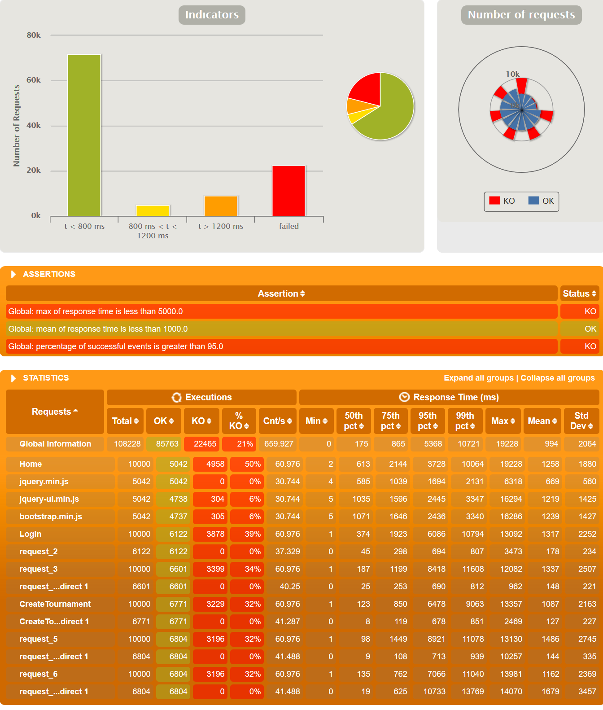

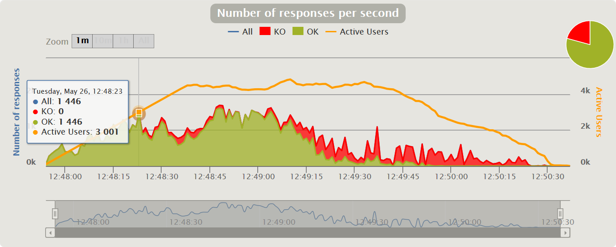

## Maximum number of concurrent users that our scenarios supports: 1100

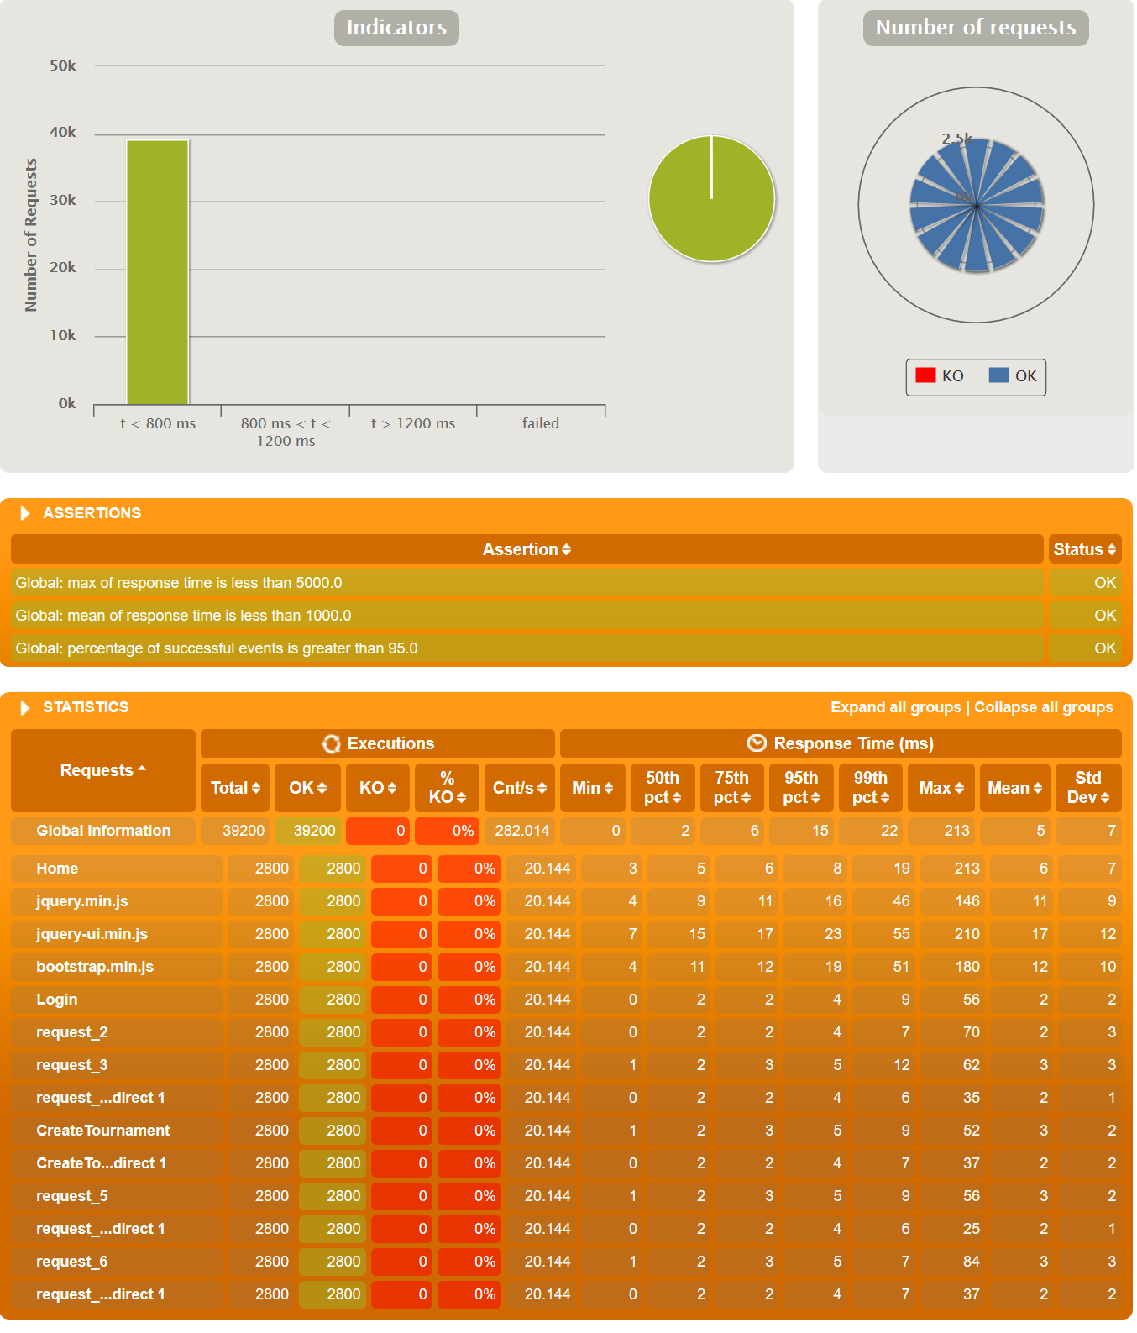

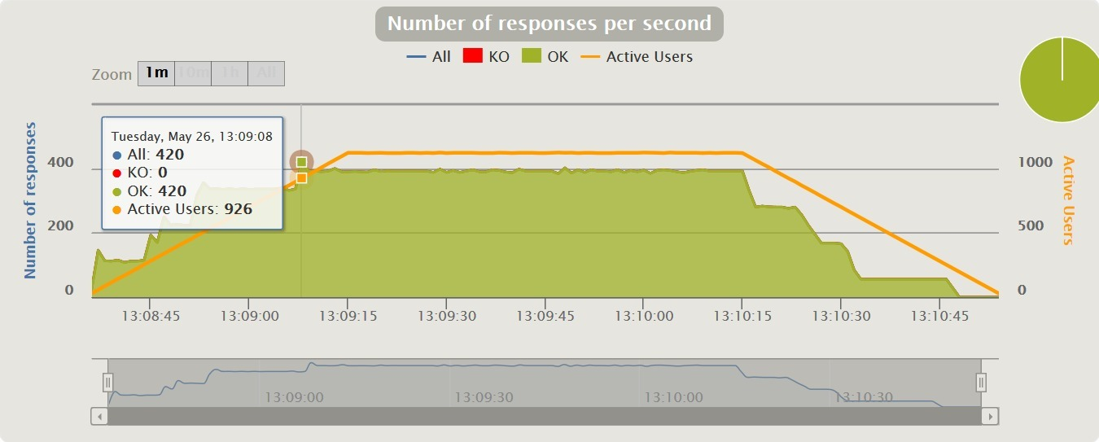

## 

## Conclusions

We can conclude that this user history has quite bad performance, since it only supports 900 users at the same time, and from 3000 it already gives serious problems.

# User Story 2 – Create a tournament category

* Positive case:
* Negative case:

## Minimum number of concurrent users that cannot be supported: 5.500

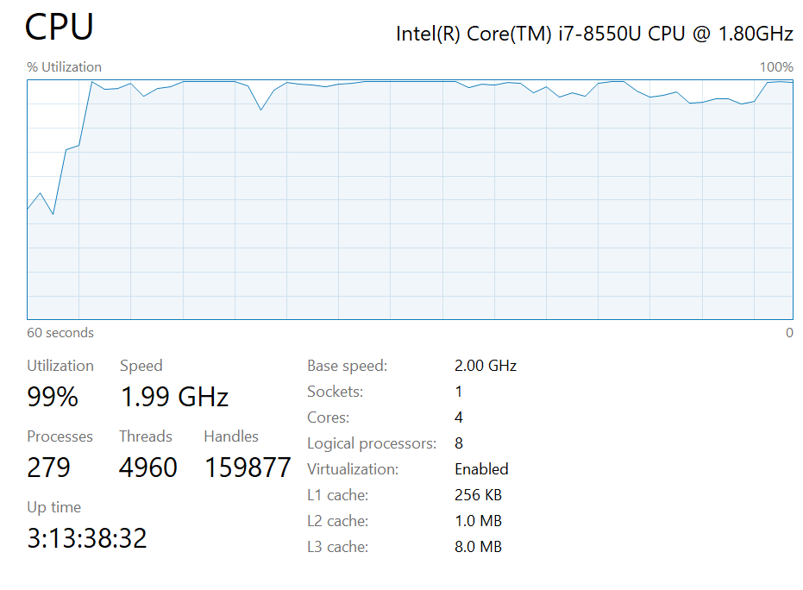

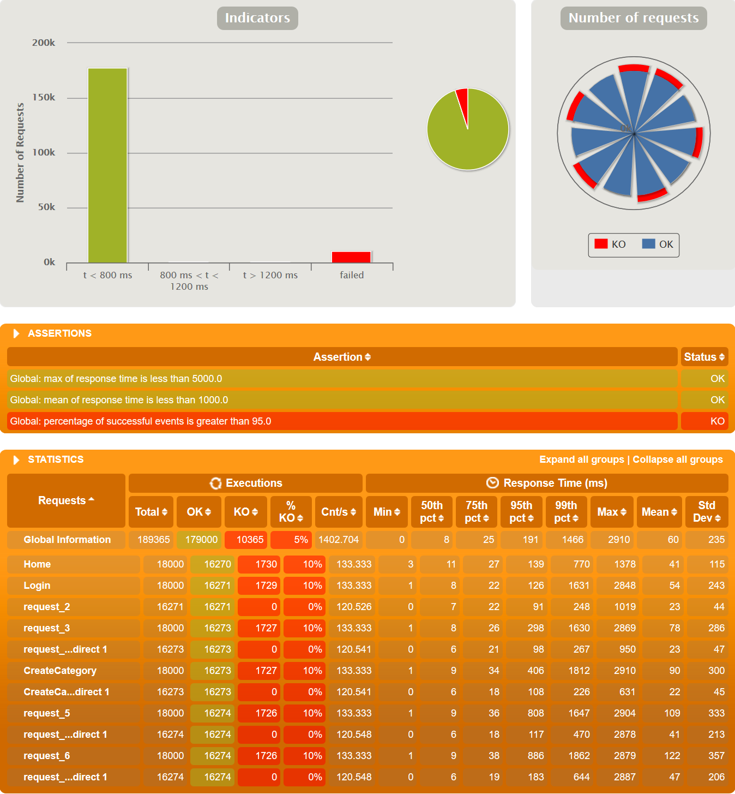

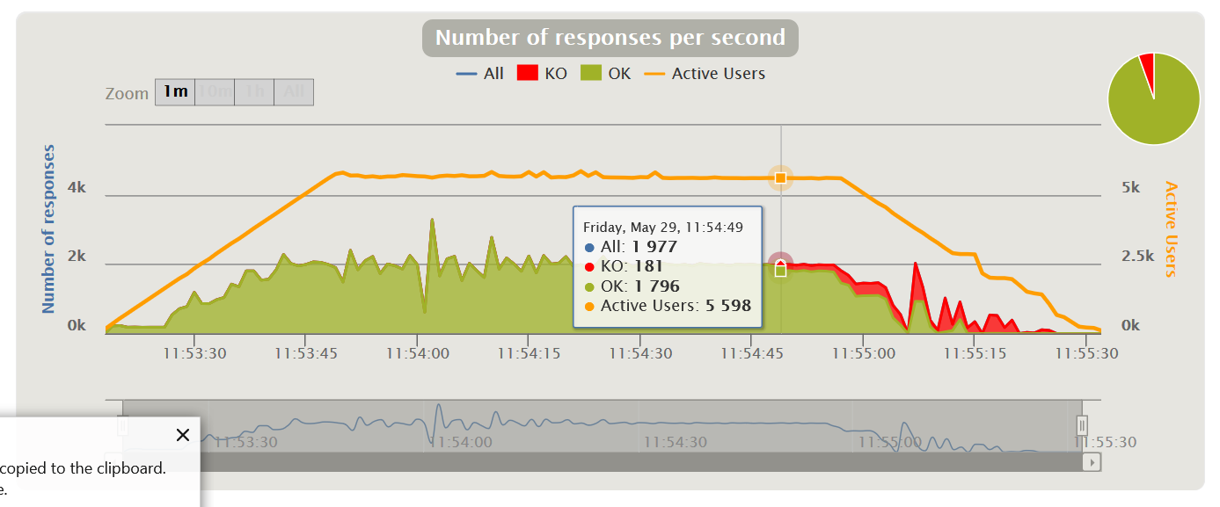

## Maximum number of concurrent users that our scenarios supports: 4.200

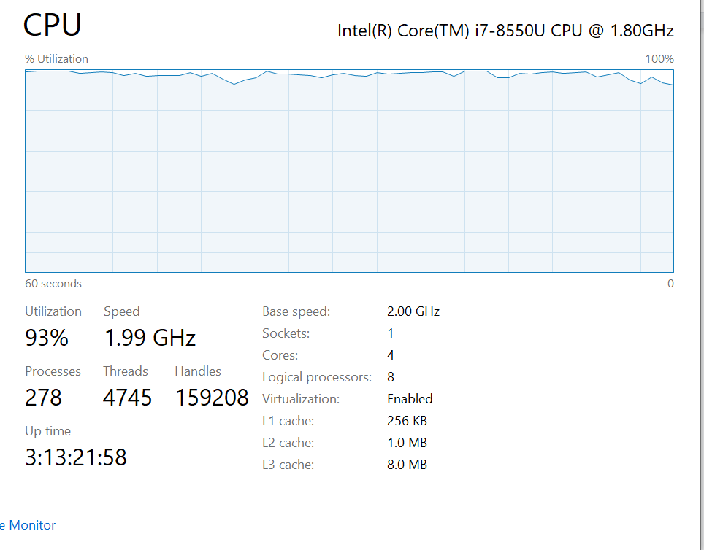

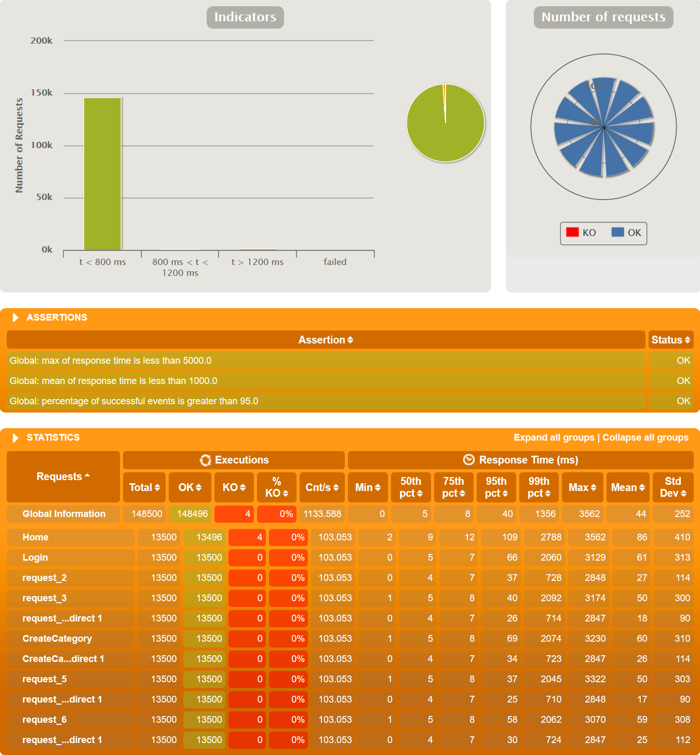

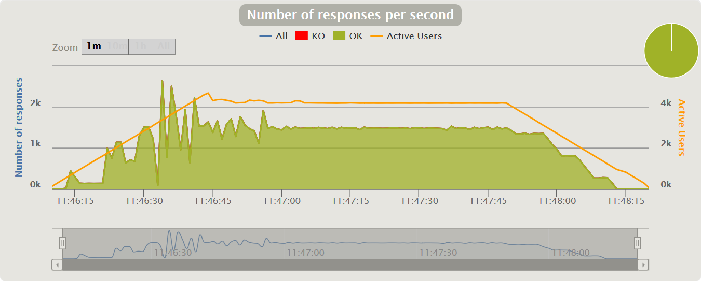

## Conclusions

We can conclude that this user history has a really good performance, since it only supports 4.200 users at the same time, and from 5.500 it already gives serious problems.

# User Story 3 – List all tournament categories

* Positive case: An admin access to the list
* Negative case: An owner access to the list

## Minimum number of concurrent users that cannot be supported: 16000

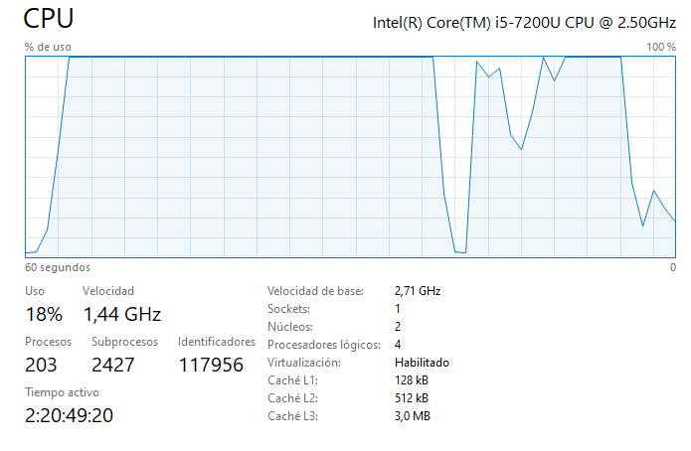

## Maximum number of concurrent users that our scenarios supports: 3583

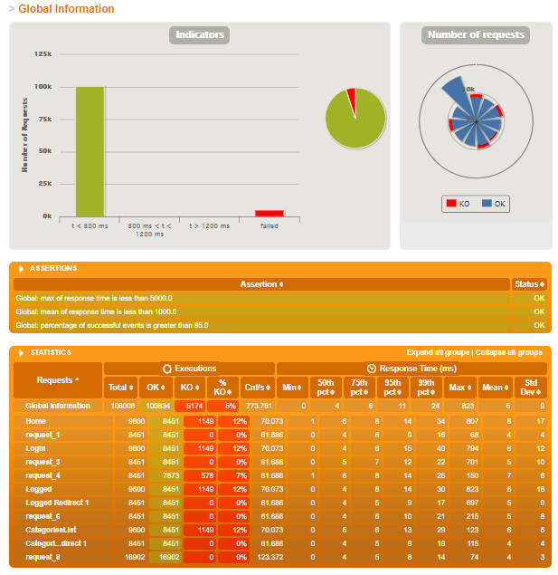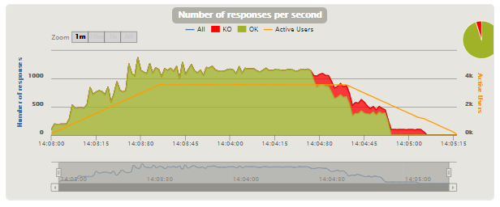

## Conclusions

We can conclude that this user history has medium performance, since it supports 3583 users at the same time, and from 16000 it already gives serious problems.

# User Story 4 – Create a tournament field

* Positive case: An admin creates a tournament
* Negative case: An user creates a tournament

## Minimum number of concurrent users that cannot be supported: 9196

Tried 20.000 owners and 20.000 admins during 100 seconds.

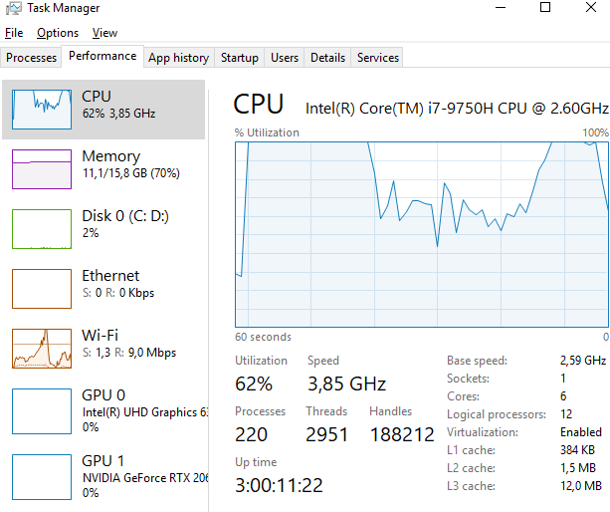

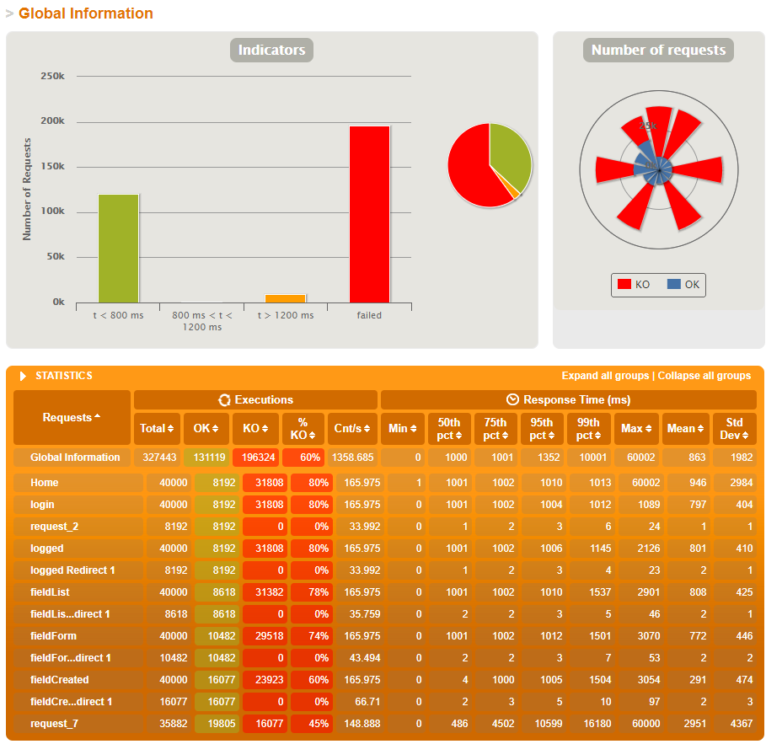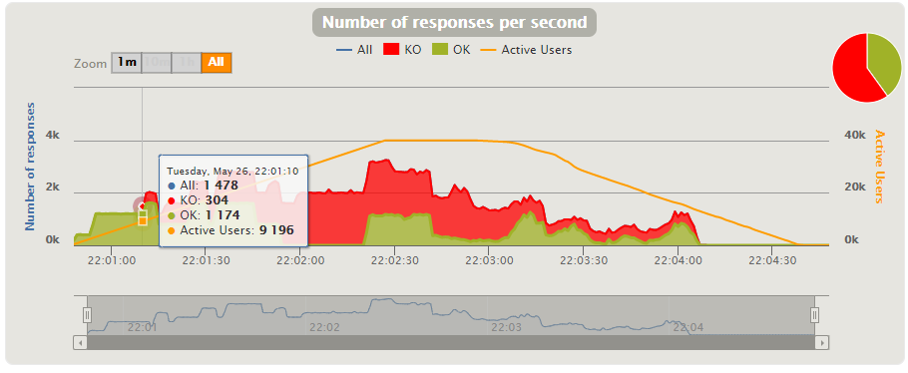

## Maximum number of concurrent users that our scenarios supports: 8556

Tried 5000 admins and 5000 owners during 90 seconds.

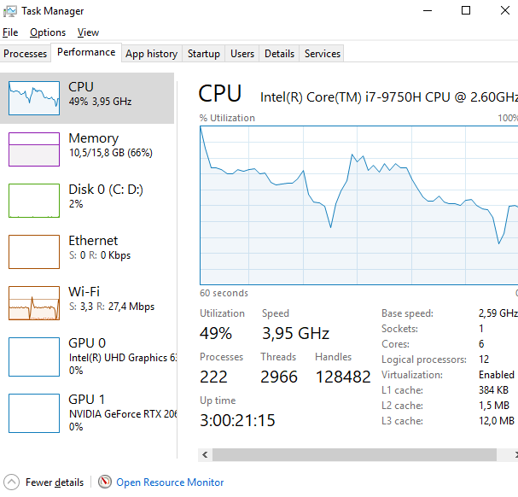

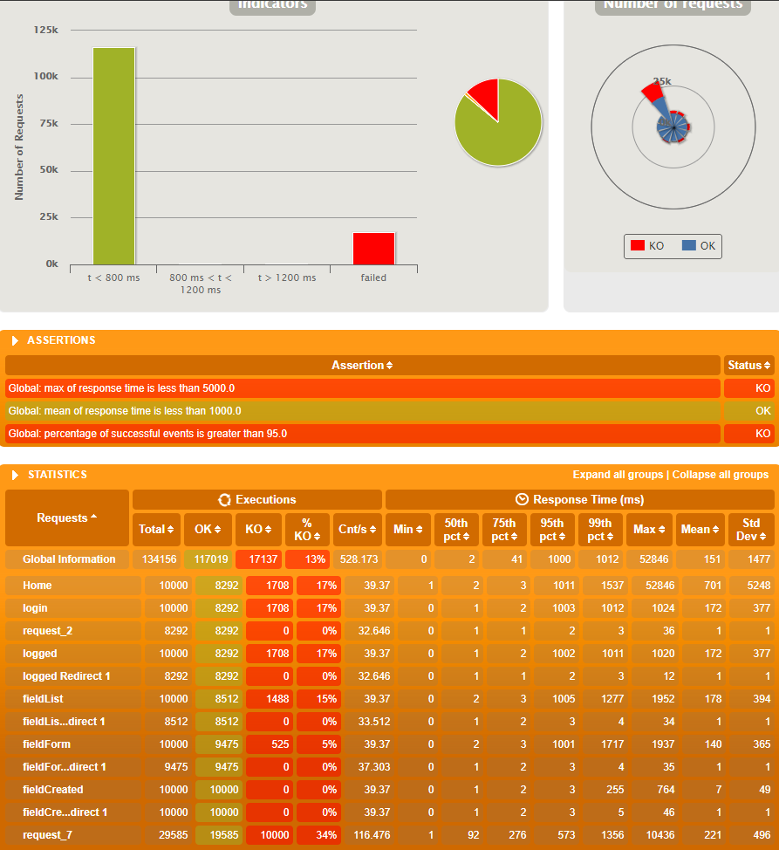

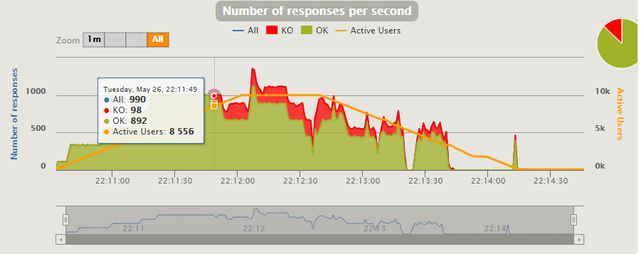

## Conclusions

It’s difficult to get a conclusion from this test, we can’t compare numbers with other tests (except UH-5, UH-6, UH-15, UH-22) since this test was executed in a way more powerful PC than the rest. The results of concurrent users that cannot be supported and concurrent users that this scenario supports are very similar to other tests ran in this PC. So I can conclude that it has an average performance.

# User Story 5 – Add a field to a tournament

* Positive case: An administrator adds a field
* Negative case: An owner adds a field

## Minimum number of concurrent users that cannot be supported: 9194

Tried 20.000 owners and 20.000 owners during 100 seconds.

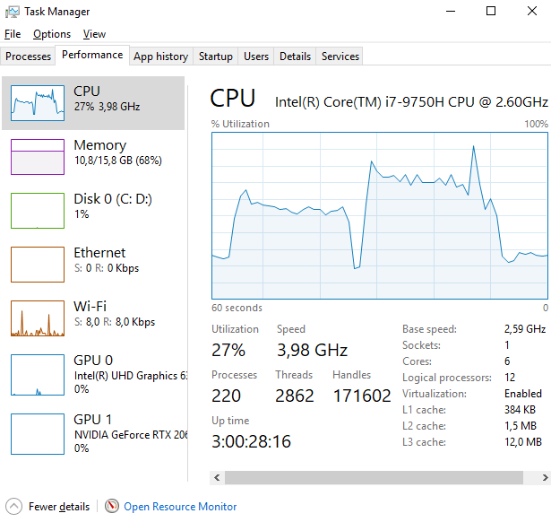

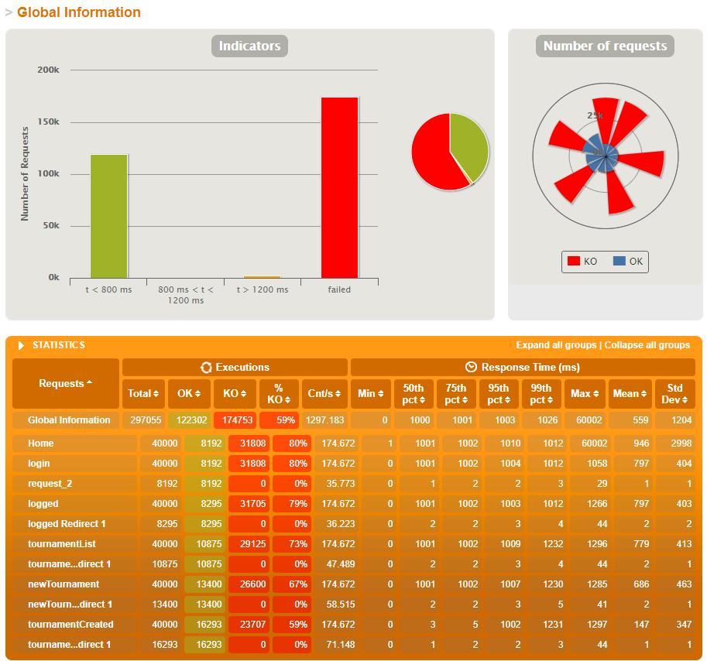

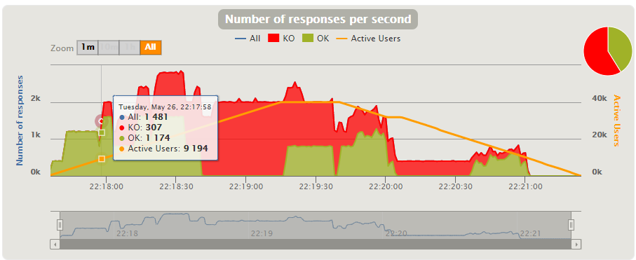

## Maximum number of concurrent users that our scenarios supports: 8556

Tried 5.000 owners and 5.000 owners during 90 seconds.

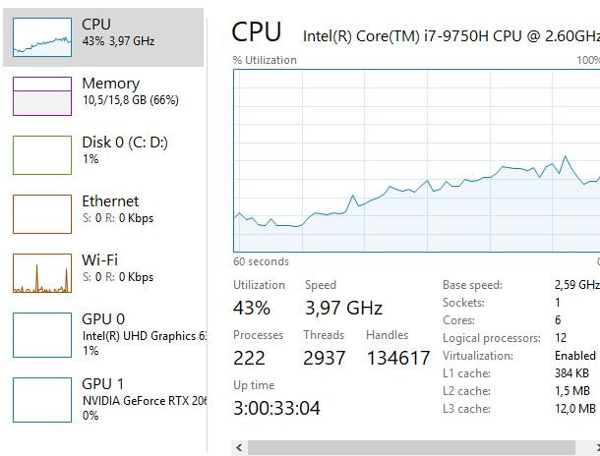

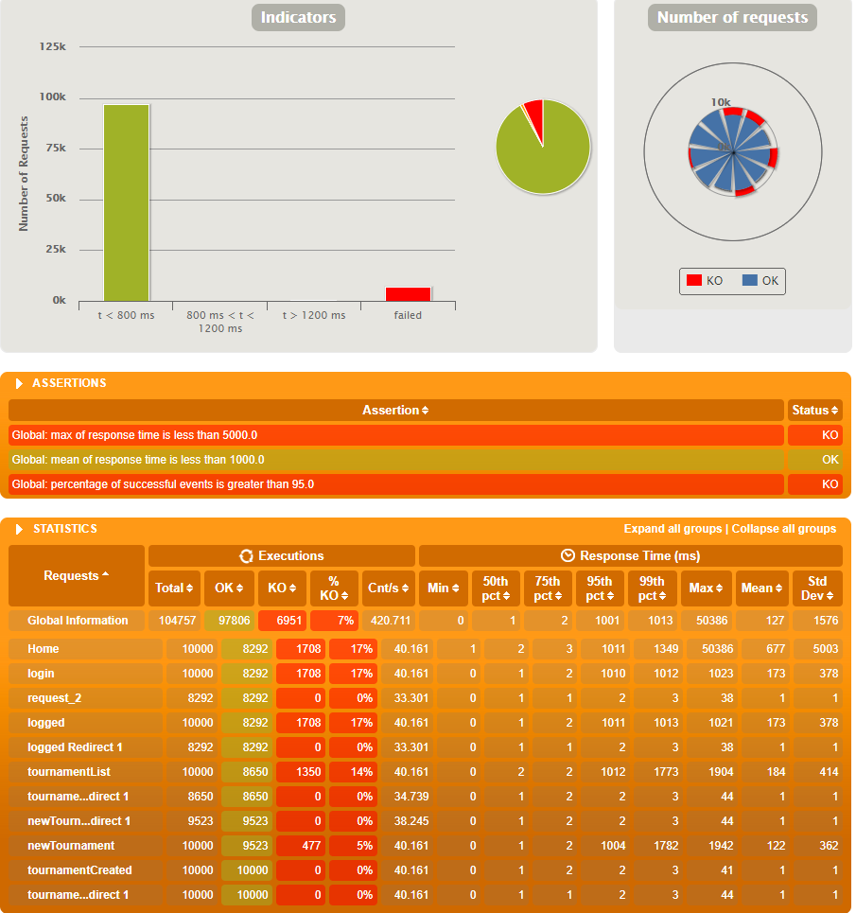

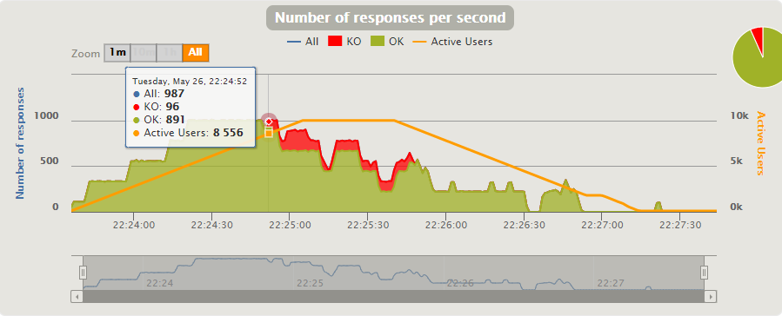

## Conclusions

It’s difficult to get a conclusion from this test, we can’t compare numbers with other tests (except UH-4, UH-6, UH-15, UH-22) since this test was executed in a way more powerful PC than the rest. The results of concurrent users that cannot be supported and concurrent users that this scenario supports are very similar to other tests ran in this PC. So I can conclude that it has an average performance.

# User Story 6 – List all tournament fields

* Positive case: an Admin access the list
* Negative case: an owner access the list

## Minimum number of concurrent users that cannot be supported: 9196

Tried 20.000 owners and 20.000 owners during 100 seconds.

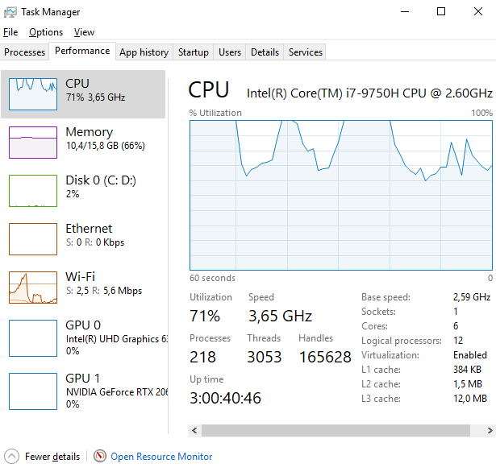

## 

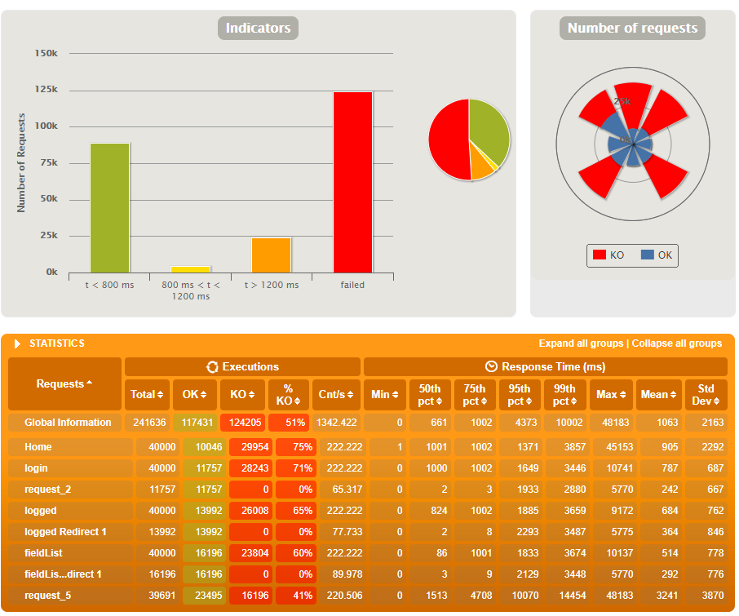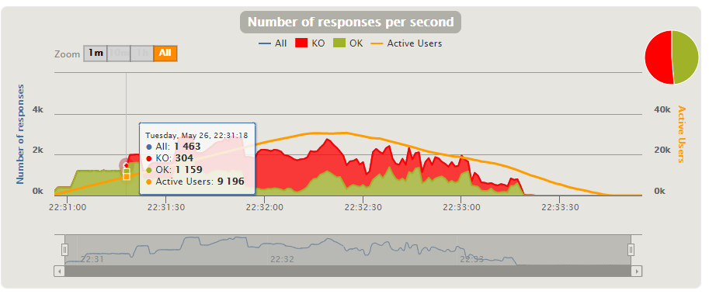

## 

## 

## Maximum number of concurrent users that our scenarios supports: 4334

Tried 5.000 owners and 5.000 owners during 90 seconds.

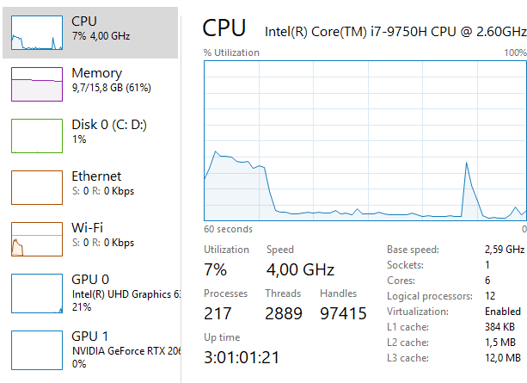

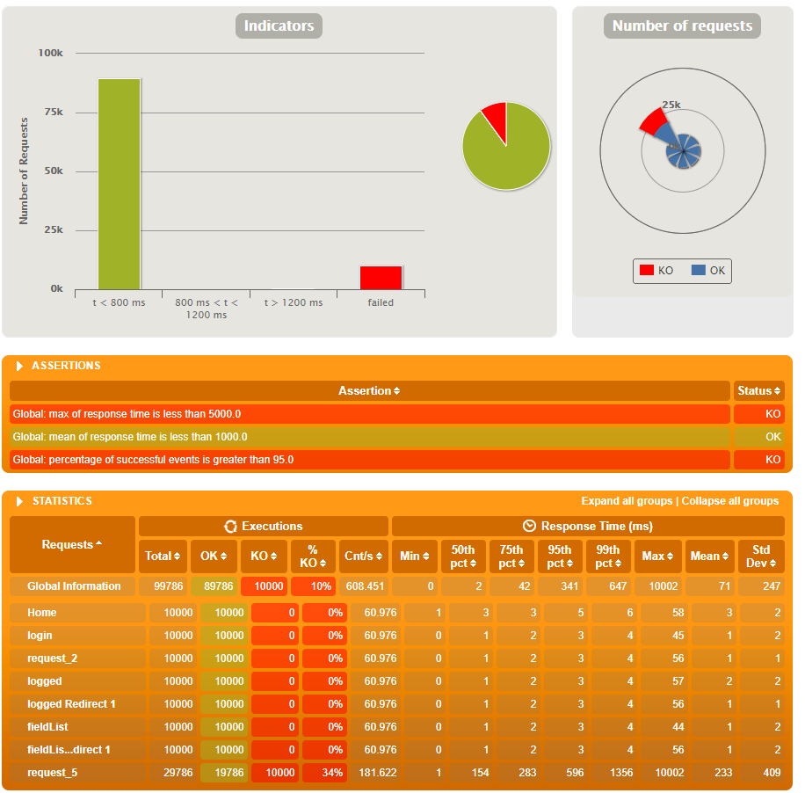

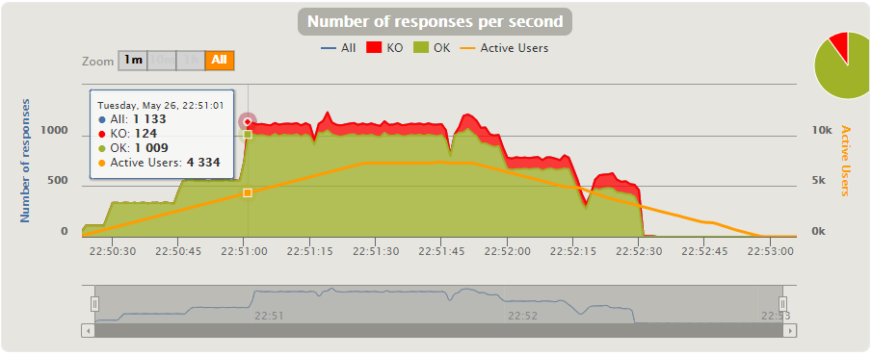

## Conclusions

It’s difficult to get a conclusion from this test, we can’t compare numbers with other tests (except UH-4, UH-5, UH-15, UH-22) since this test was executed in a way more powerful PC than the rest. The results of concurrent users that cannot be supported is very similar to other tests executed in this PC, however, the number of users this scenario supports is way lower than other tests executed in this PC, so I conclude it has bad performance, this may be due to having to load images for every Field in the Field List.

# User Story 7 – Assign a judge to a tournament

* Positive case: When you are authenticated as administrator, try to update a tournament by assigning the judge with the last name "Dredd", location "York", application date "2020/10/10", start date "2020/11/01" and end date "2020/11/03" and a prize of "150.00 EUR" , the other data remain the same.
* Negative case: When you are authenticated as administrator, try to update the same tournament by assigning the judge with the last name "Dredd" with application date "2020/12/02" the other data remains the same and it returns to the form.

## Minimum number of concurrent users that cannot be supported: 8588

Tested for 9000 users for each scenario

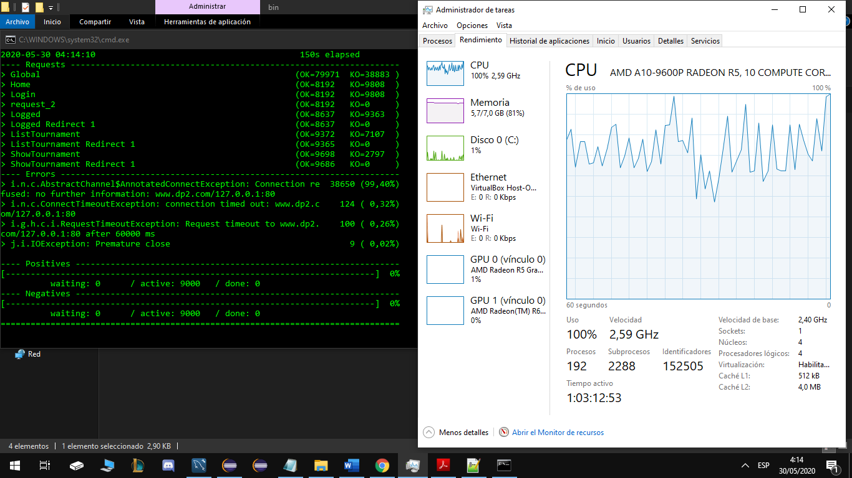

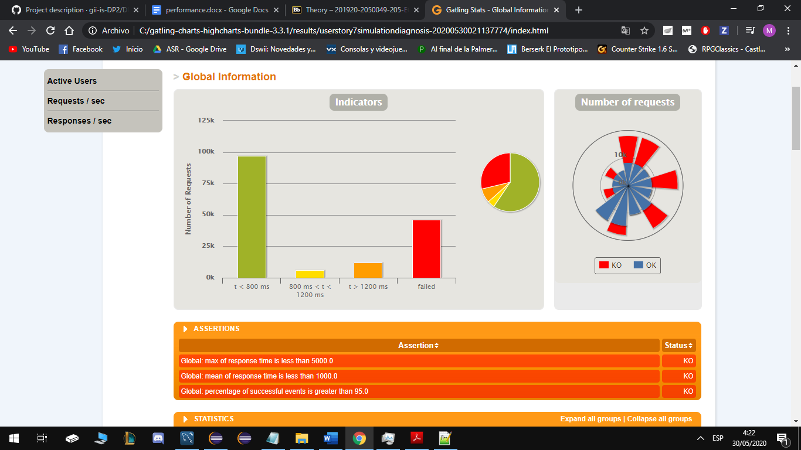

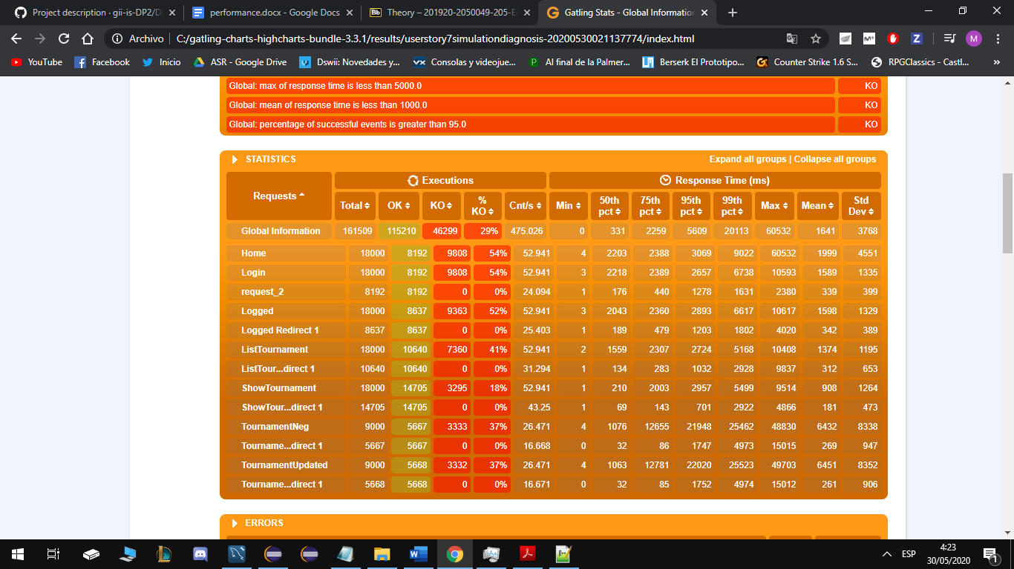

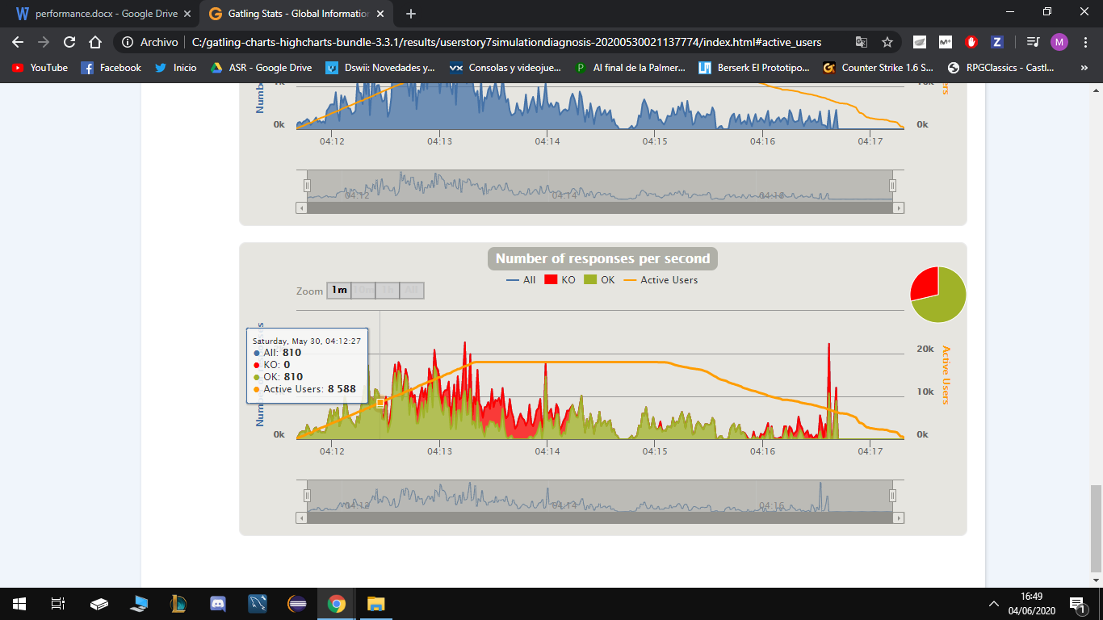

## Maximum number of concurrent users that our scenarios supports: 6000

Tested for 4000 users in each scenario during 100 seconds.

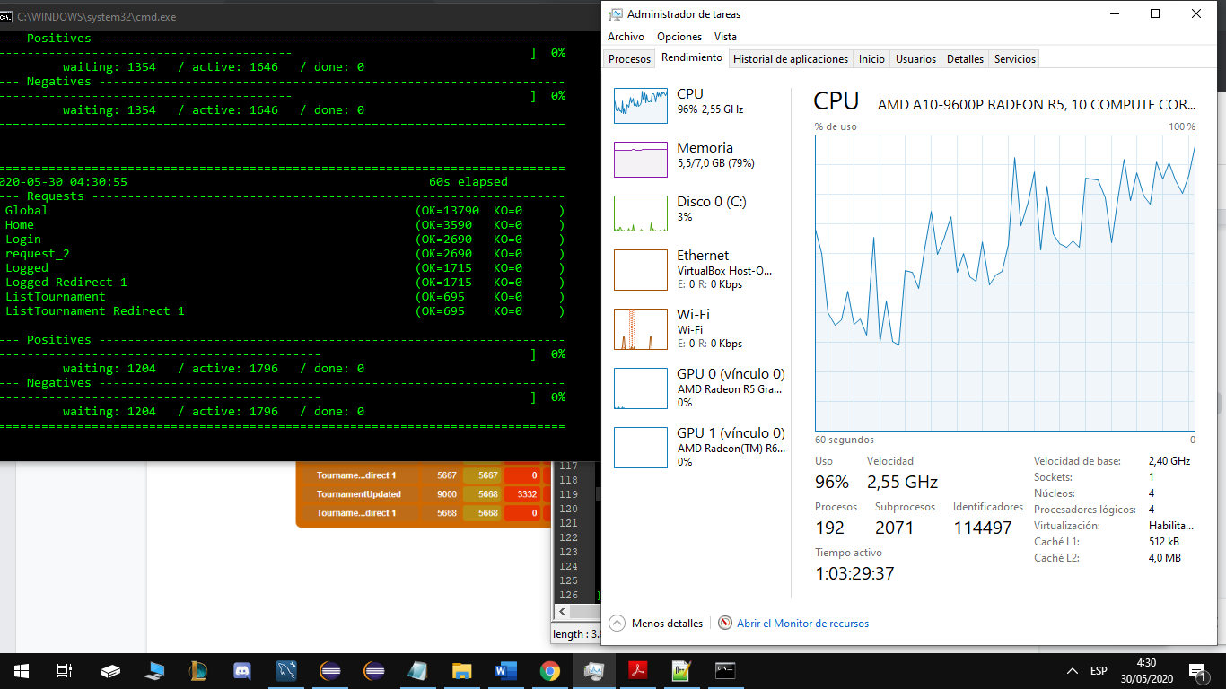

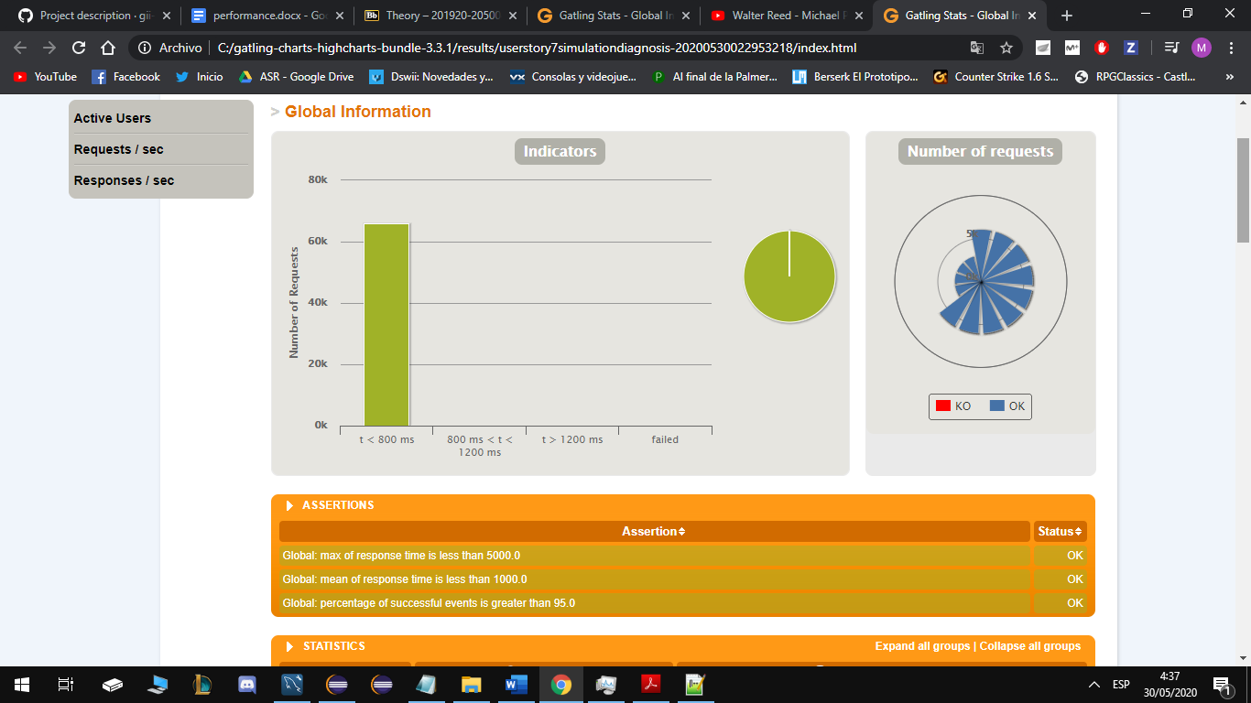

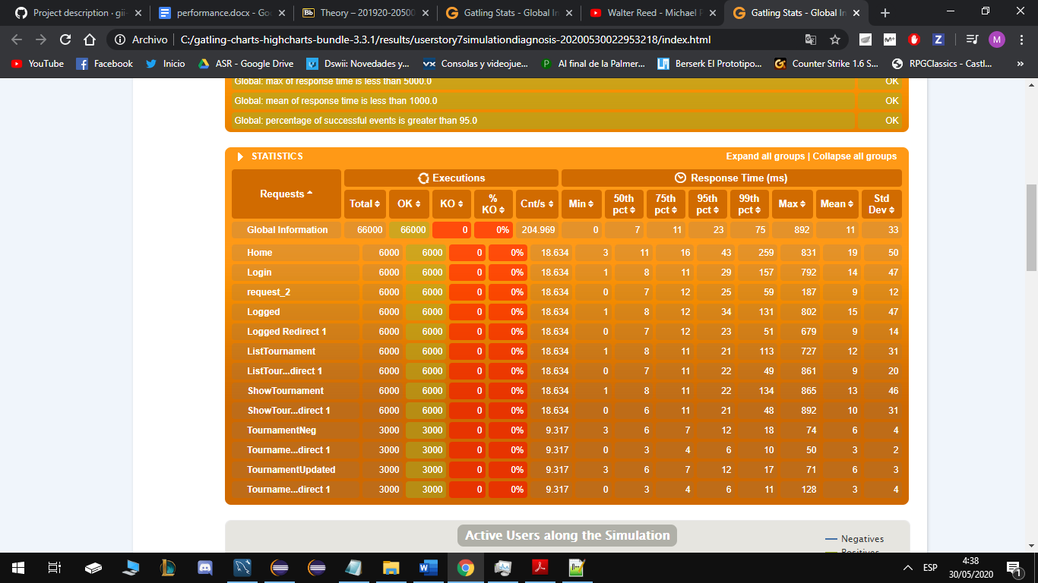

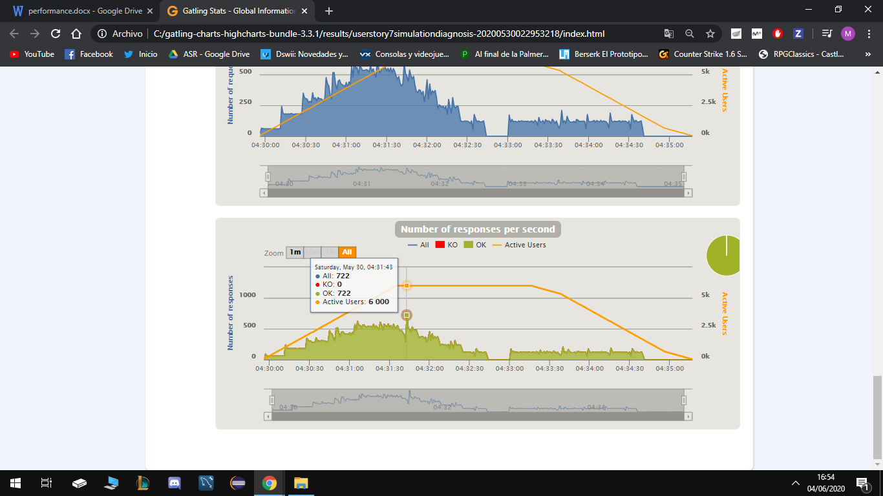

## Conclusions

We can conclude that this user history has a good performance, it supports 6.000 users at the same time, and from 8588 it already gives problems with my computer’s technical specifications.

# User Story 8 – Show the list of all applications of system

* Positive case: authenticated as an Admin
* Negative case: authenticated as an Owners

## Minimum number of concurrent users that cannot be supported: 10060

Tested for 15000

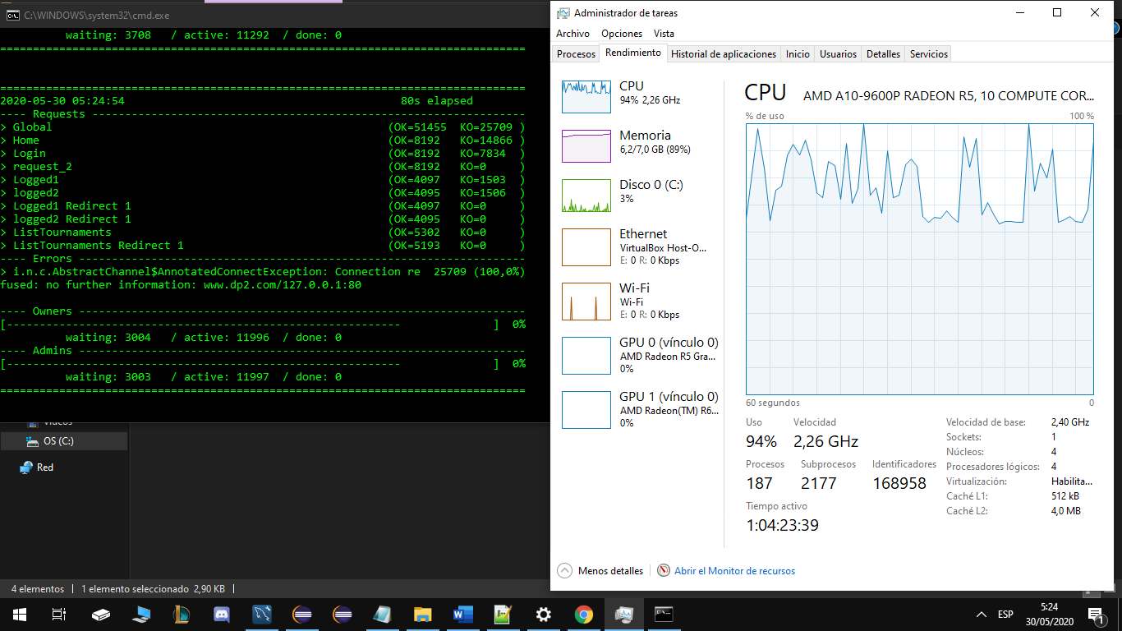

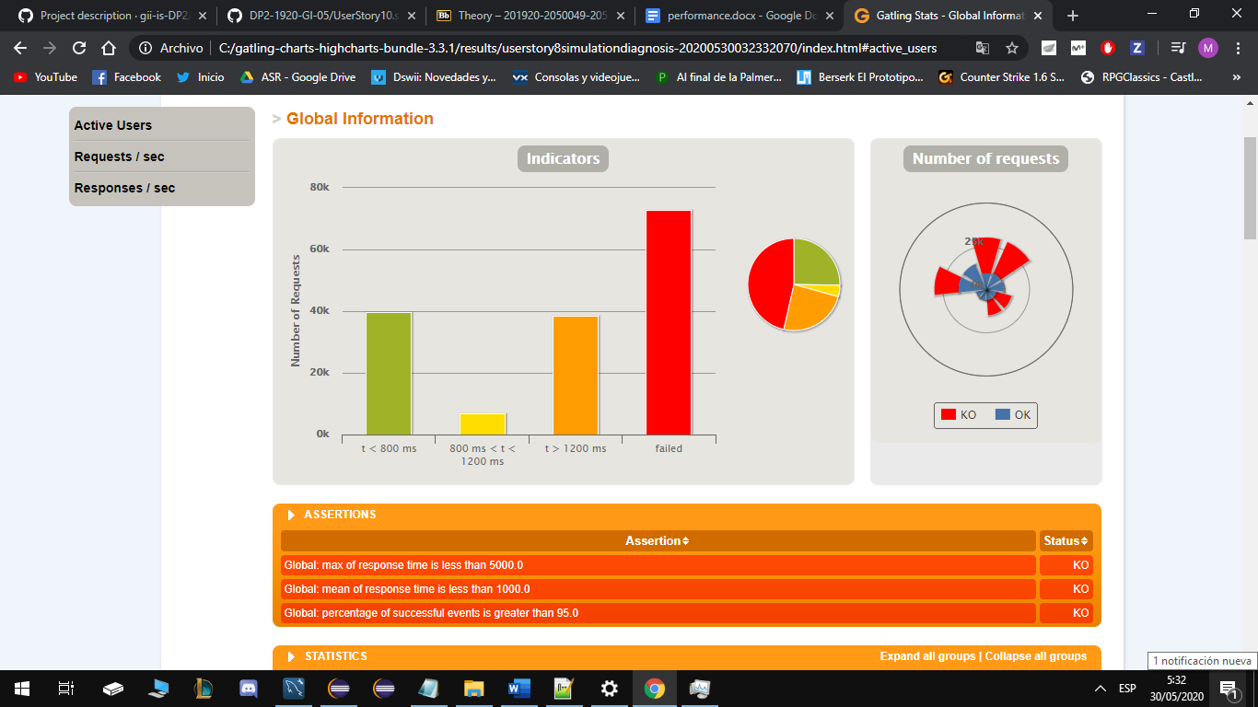

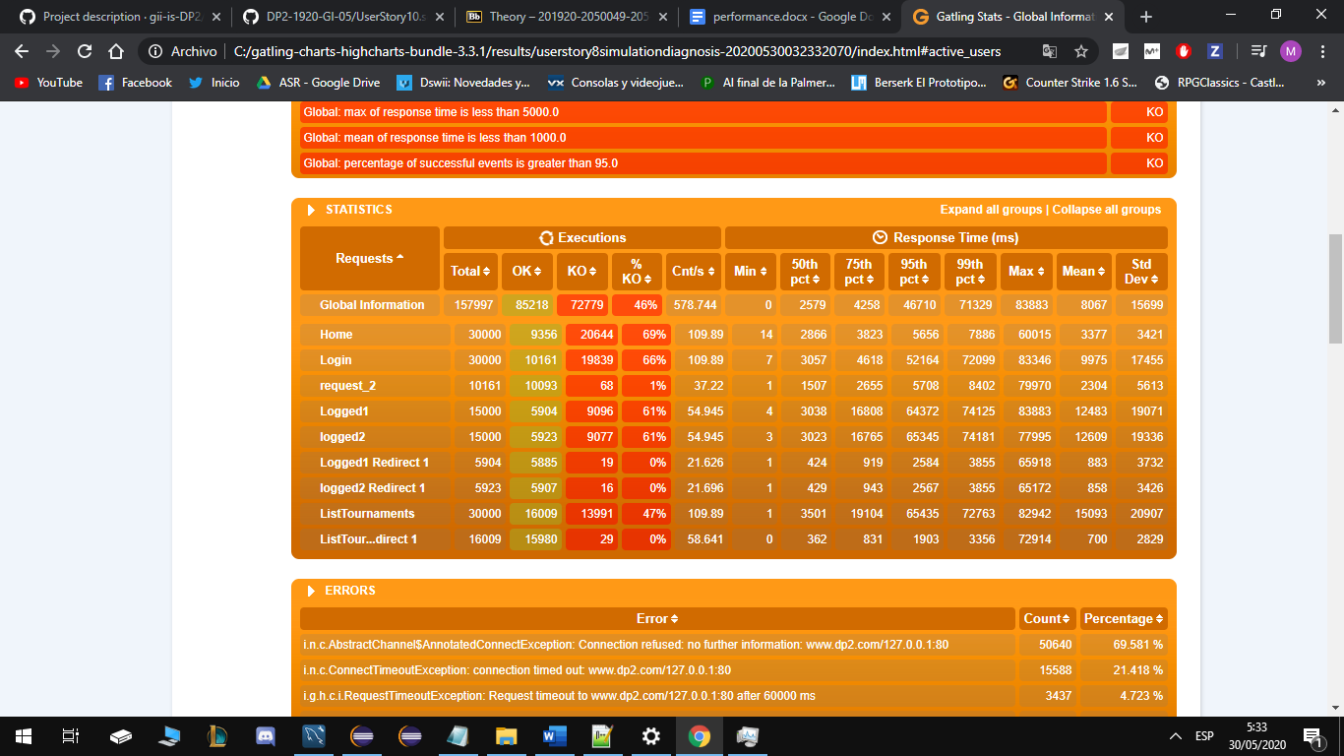

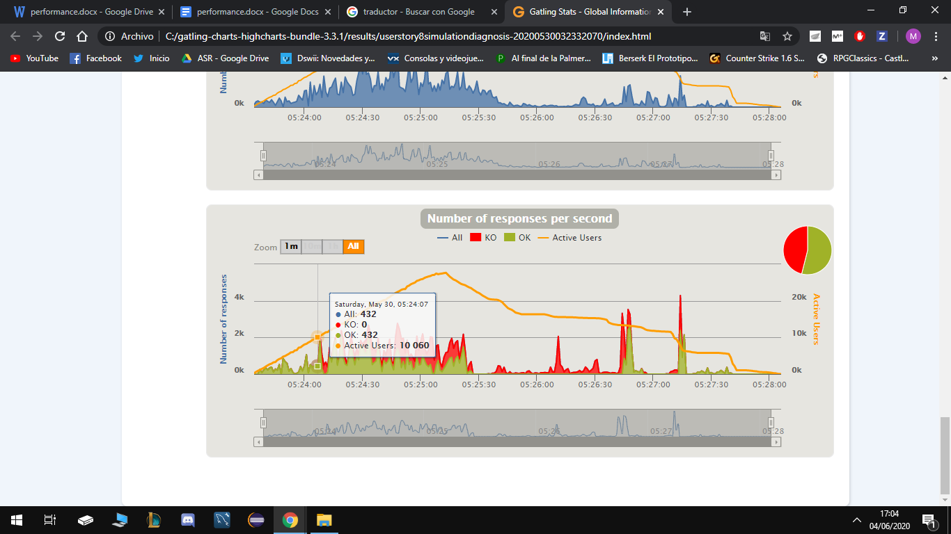

## Maximum number of concurrent users that our scenarios supports: 5116

Tested for 4000

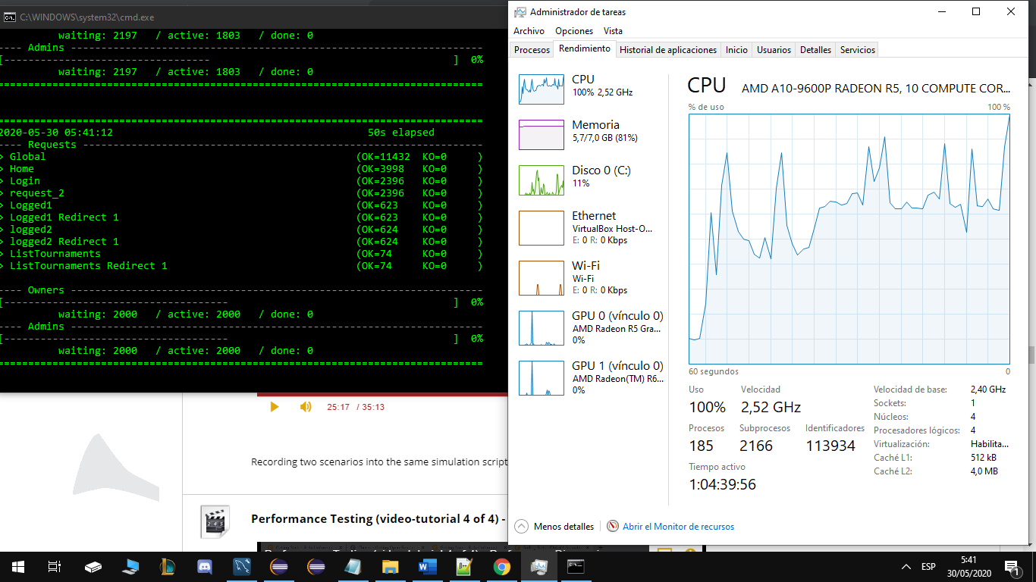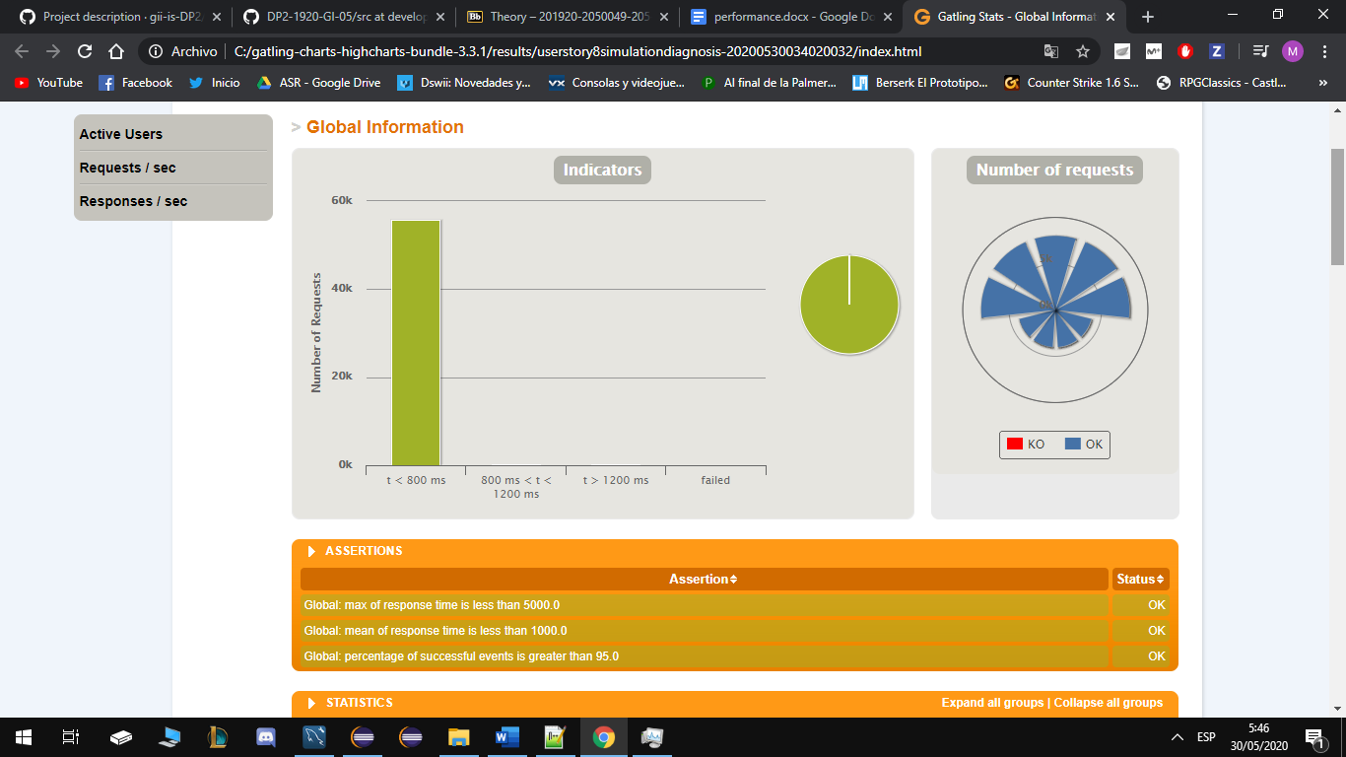

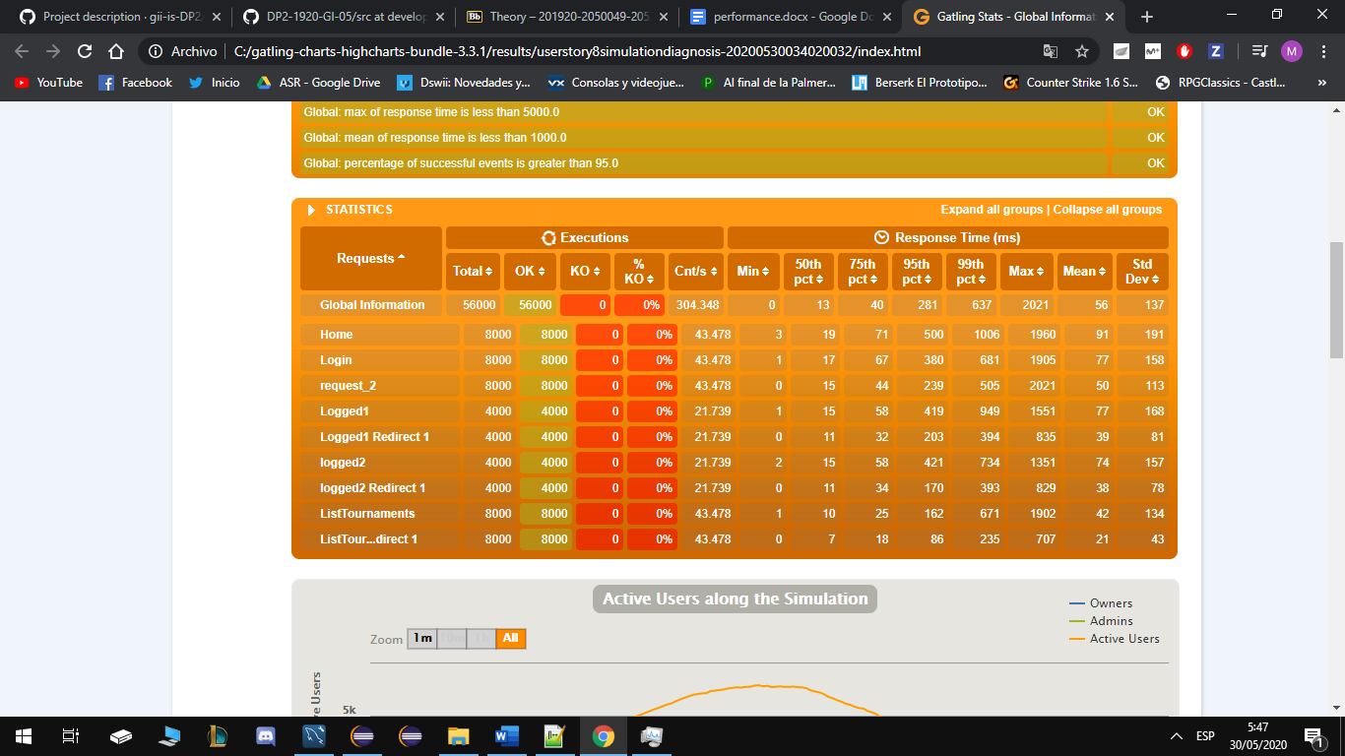

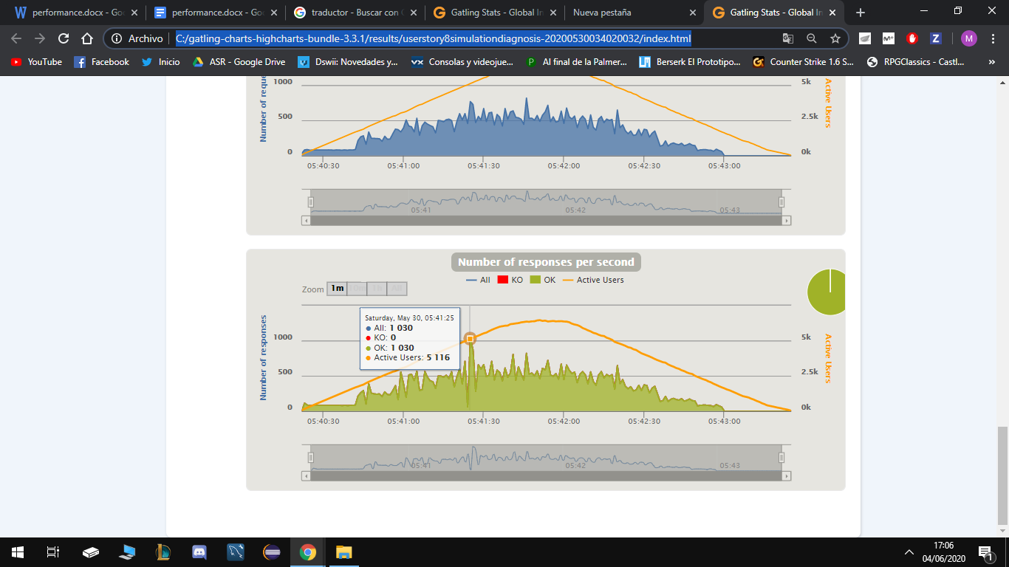

## Conclusions

We can conclude that this user history has a good performance, it supports 5116 users at the same time, and from 10060 it already gives problems with my computer’s technical specifications. Assuming that 5000 concurrent users with my technical specifications is a good number.

# User Story 9 – Update application

* Positive case: Update the application for an active tournament.
* Negative case: Update the application for an old tournament.

## Minimum number of concurrent users that cannot be supported: 9160

Tested for 9000 users for each scenario

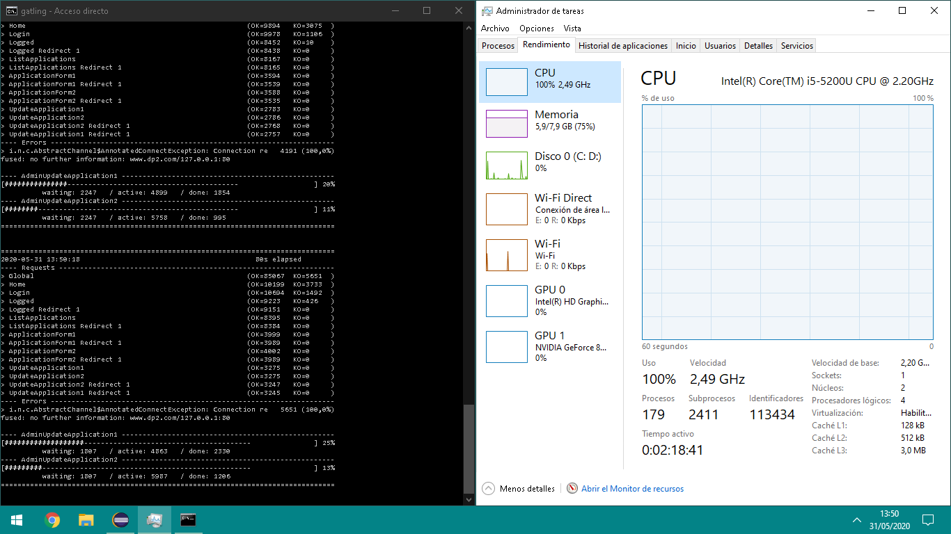

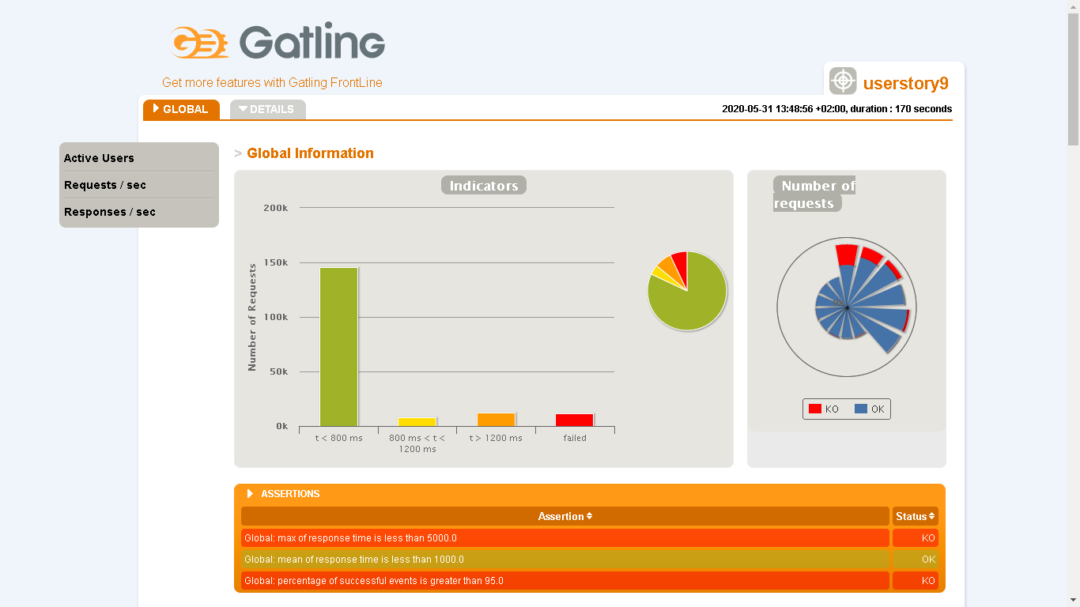

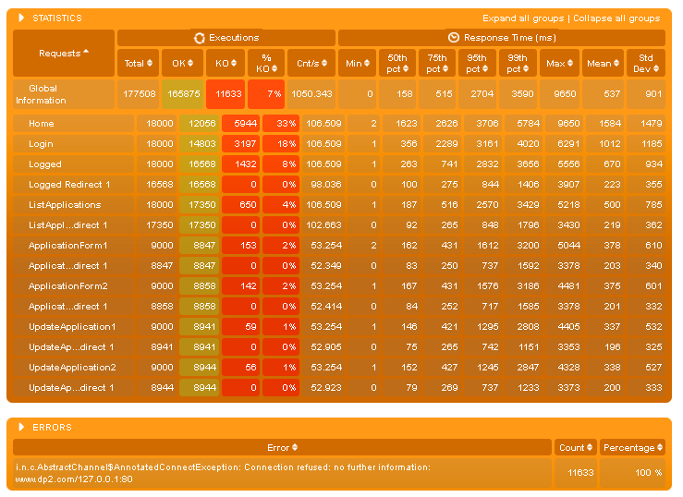

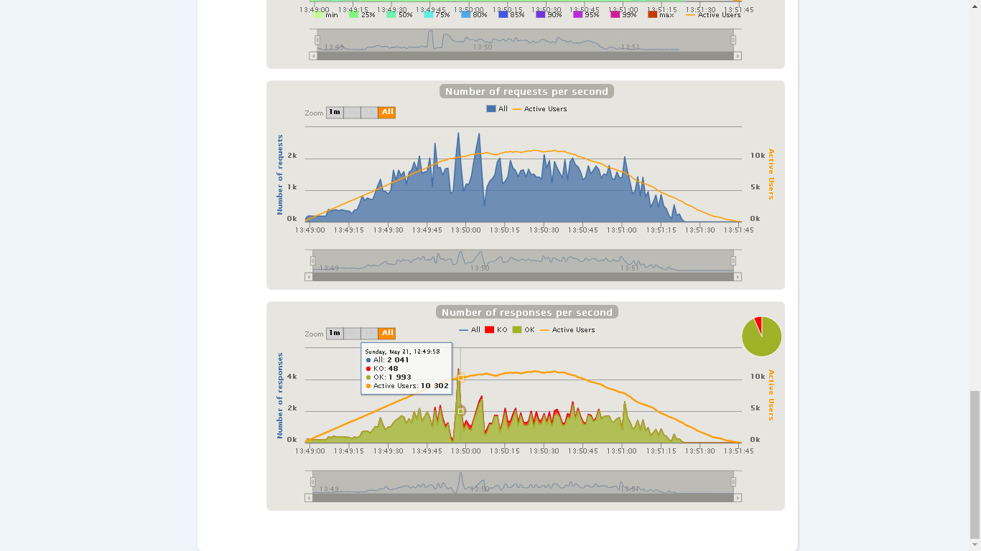

# 

## 

## Maximum number of concurrent users that our scenarios supports: 7184

Tested for 6000 users for each scenario.

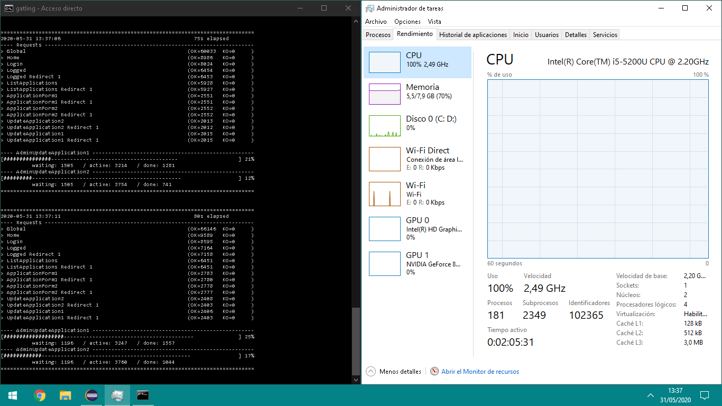

Stats

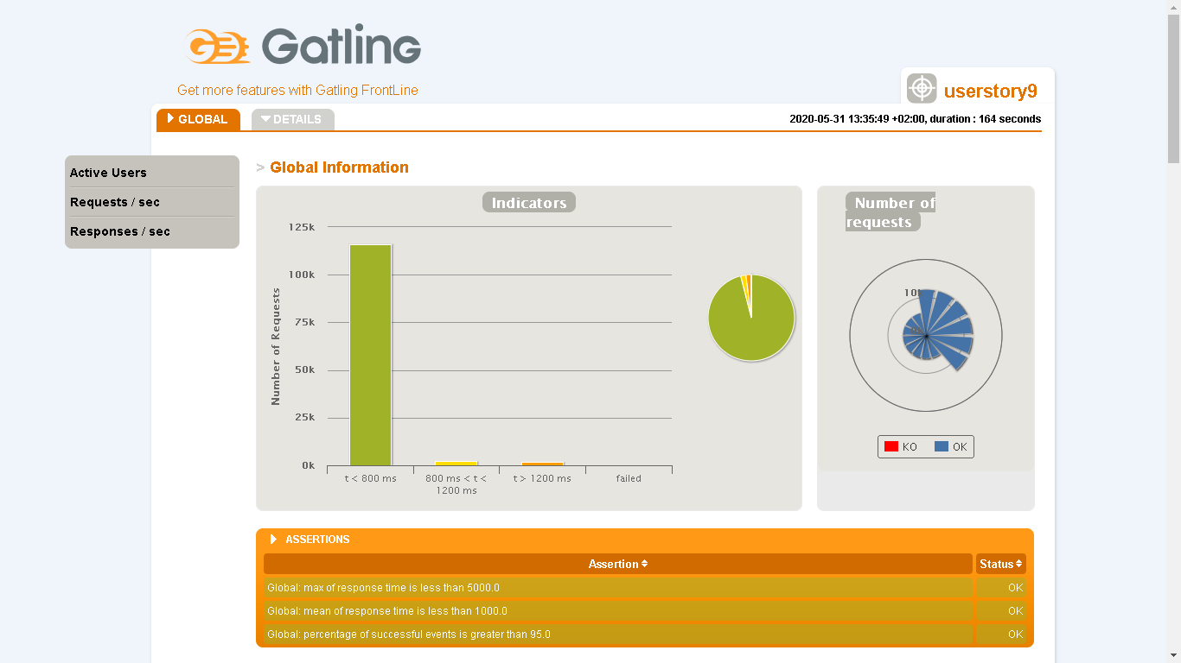

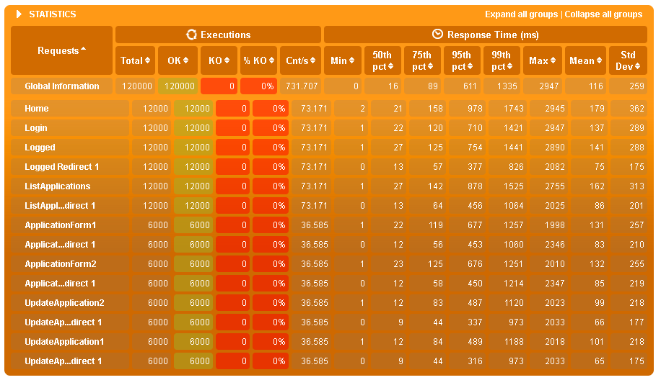

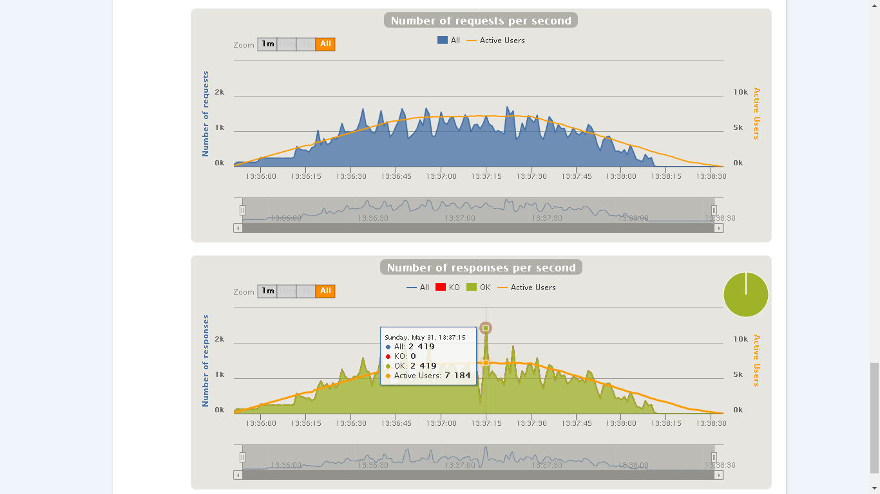

## Conclusions

To be a user story that loads a @ModelAttribute when it runs, it shows acceptable performance, for a number of users in each scenario between 6000-9000, it shows poor performance with a percentage of KOs sometimes higher than 5%.

# User Story 10 – Show the list of all tournaments of system

* Positive case: Access as admin to see the list.
* Negative case: Access as owner to see the list.

## Minimum number of concurrent users that cannot be supported: 9878

Tested for 14000 users for each scenario.

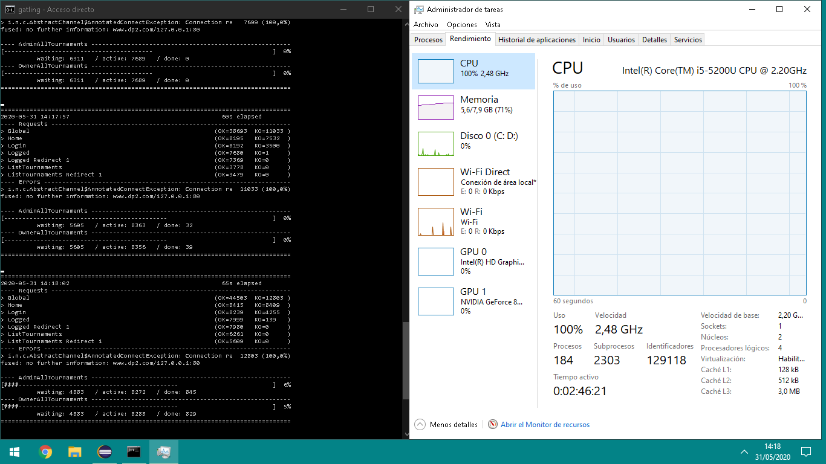

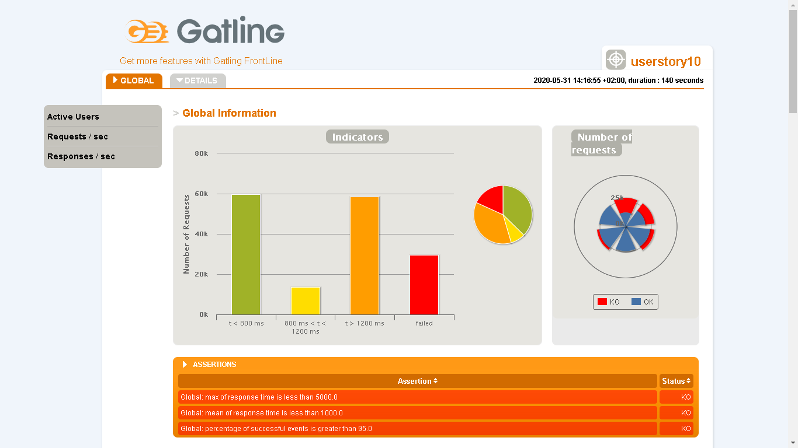

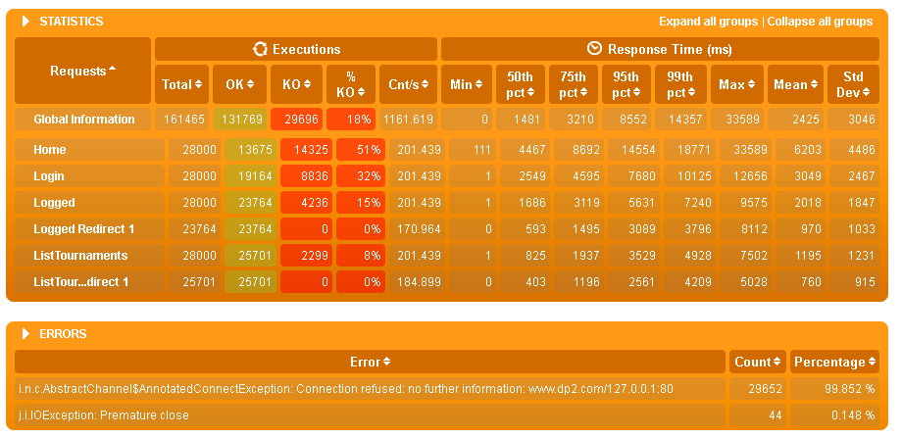

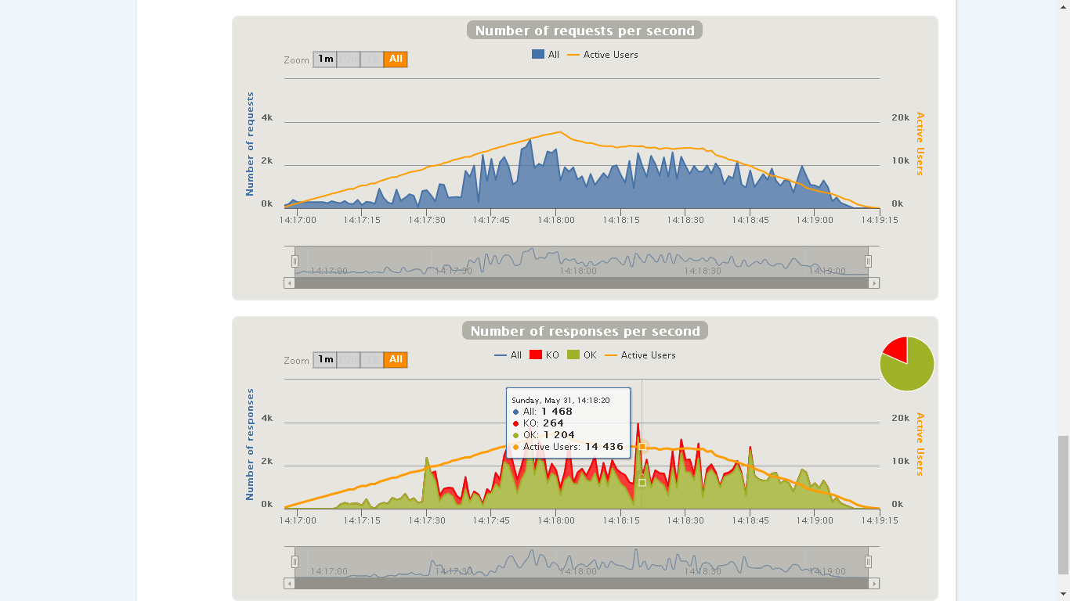

## Maximum number of concurrent users that our scenarios supports: 7601

Tested for 10000 users for each scenario.

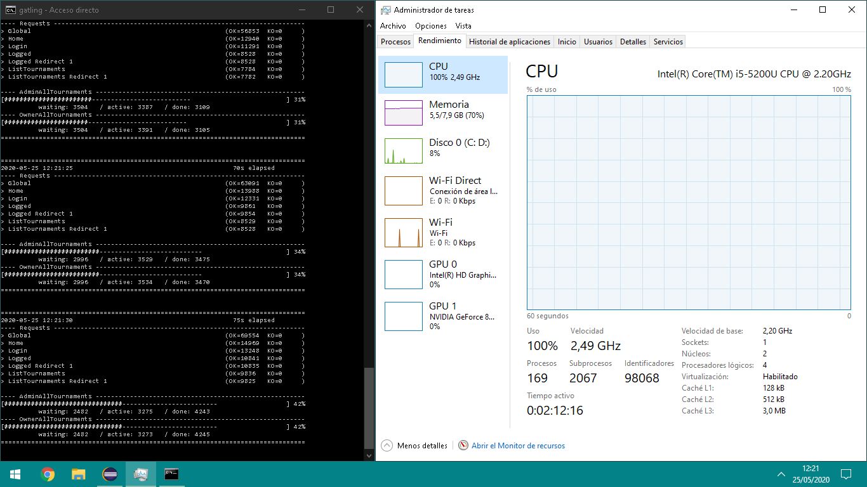

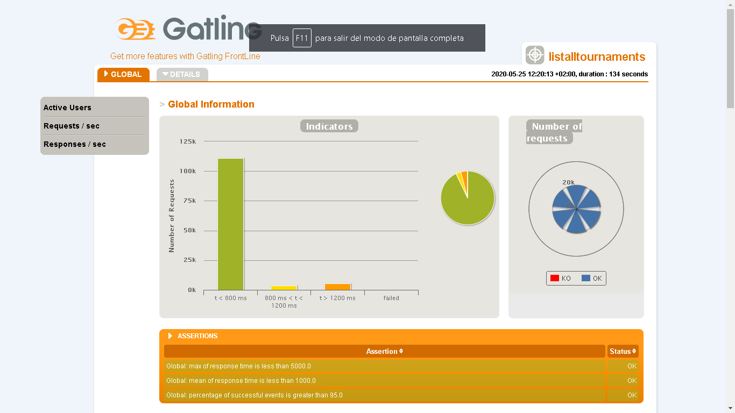

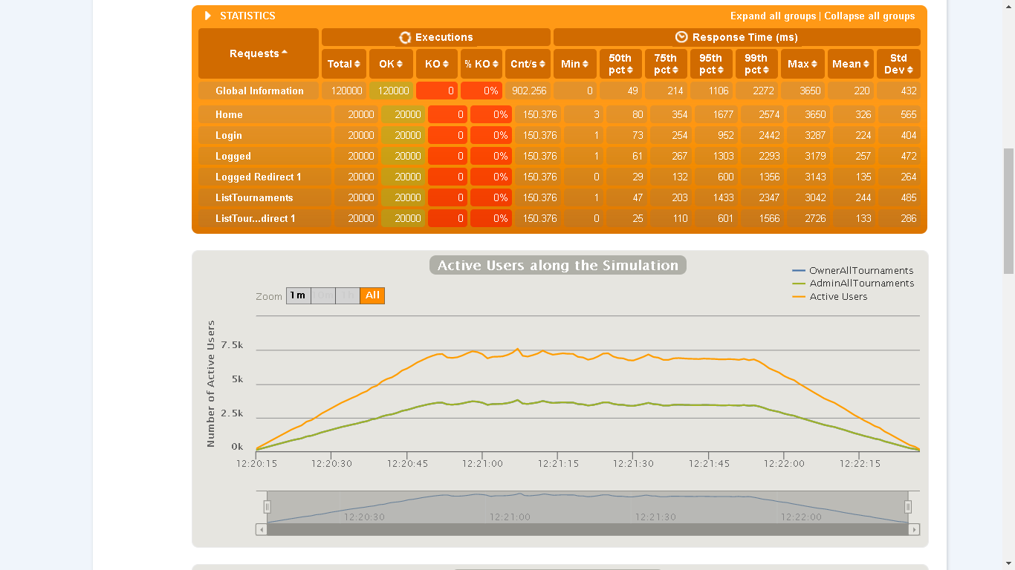

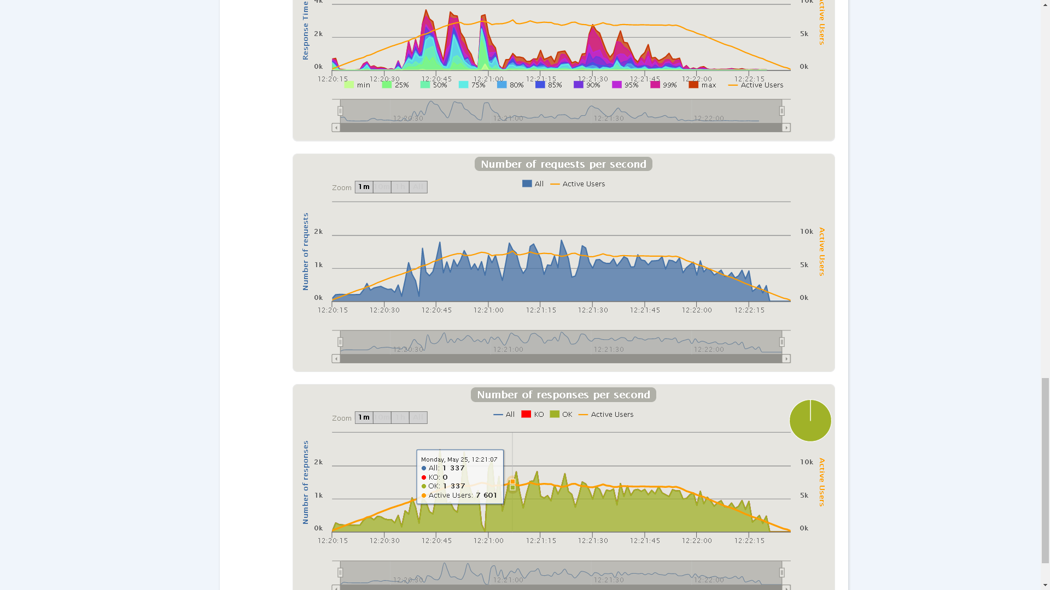

## Conclusions

This user story shows good performance as expected, supports a large number of users and stops working with 4000 more users, most KOs arise in the Home and Login transition.

# User Story 11 – Show the list of active tournaments

* Positive case: Access as owner to see the list.
* Negative case: Access as Anonymous user to see the list.

## Minimum number of concurrent users that cannot be supported: 9489

Tested for 17000 users for each scenario

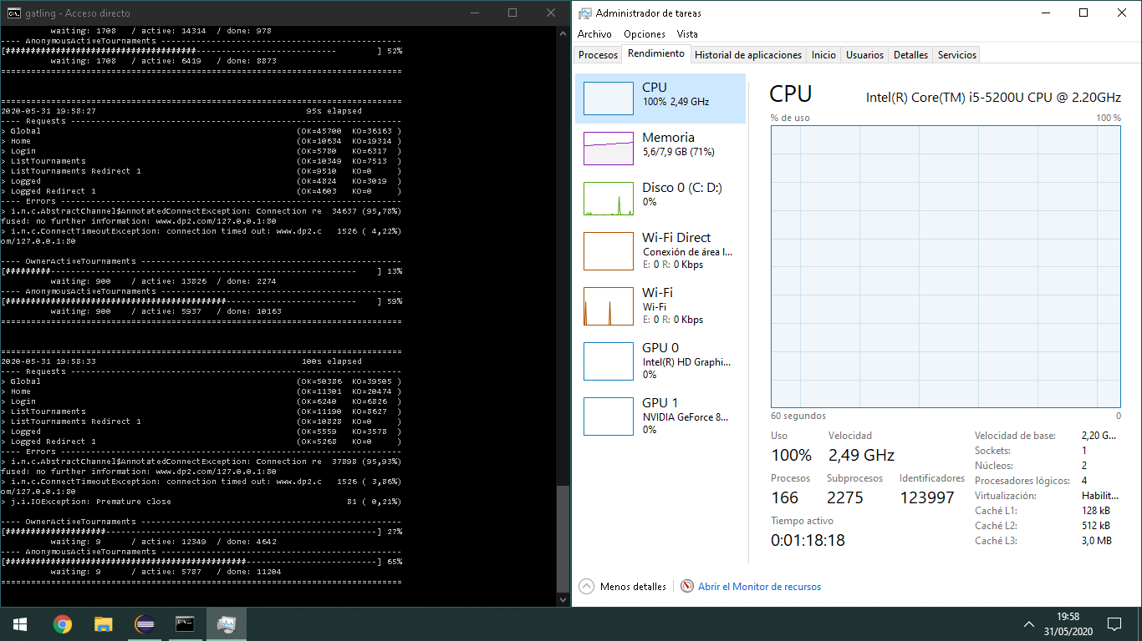

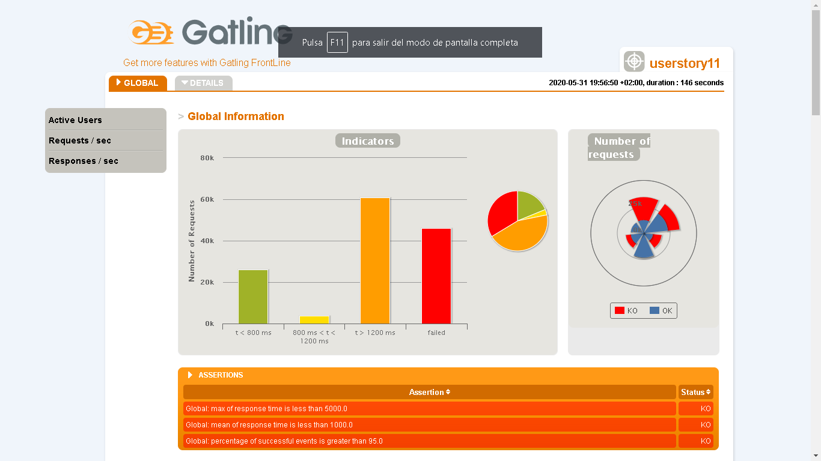

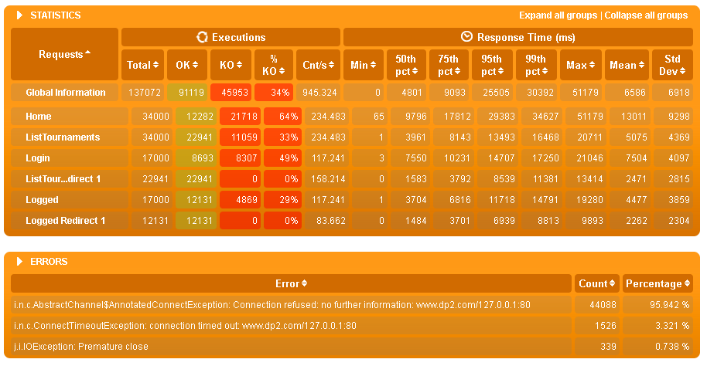

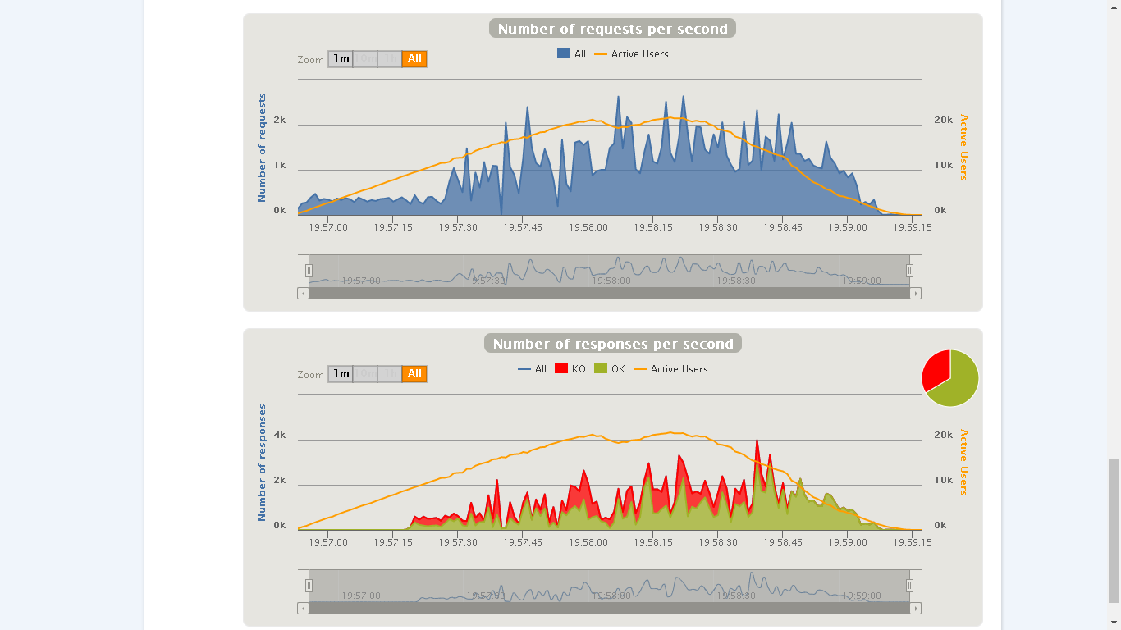

## Maximum number of concurrent users that our scenarios supports: 6692

Tested for 12000 users for each scenario, for tests with higher values ​​the maximum response time was greater than 5000 .

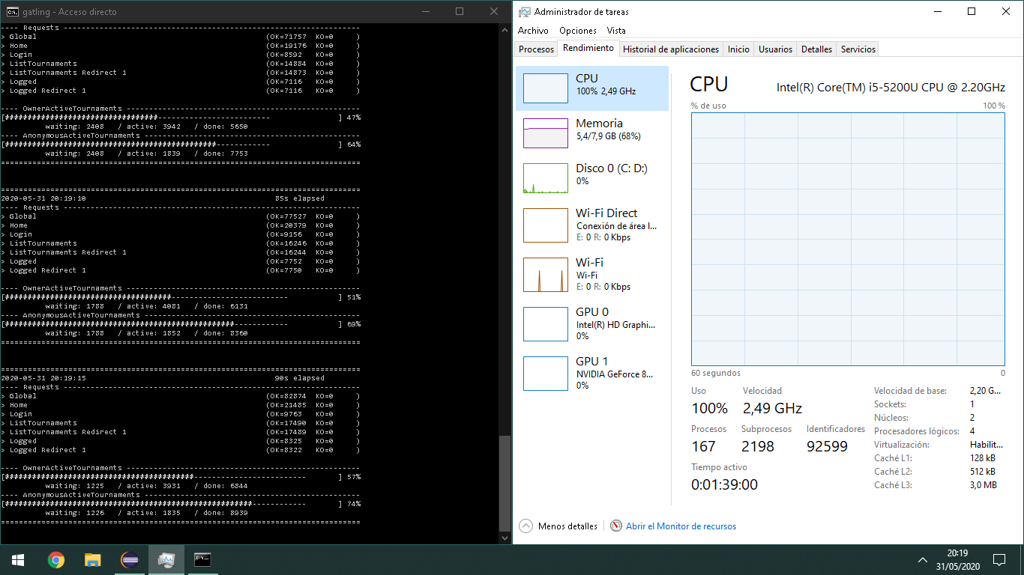

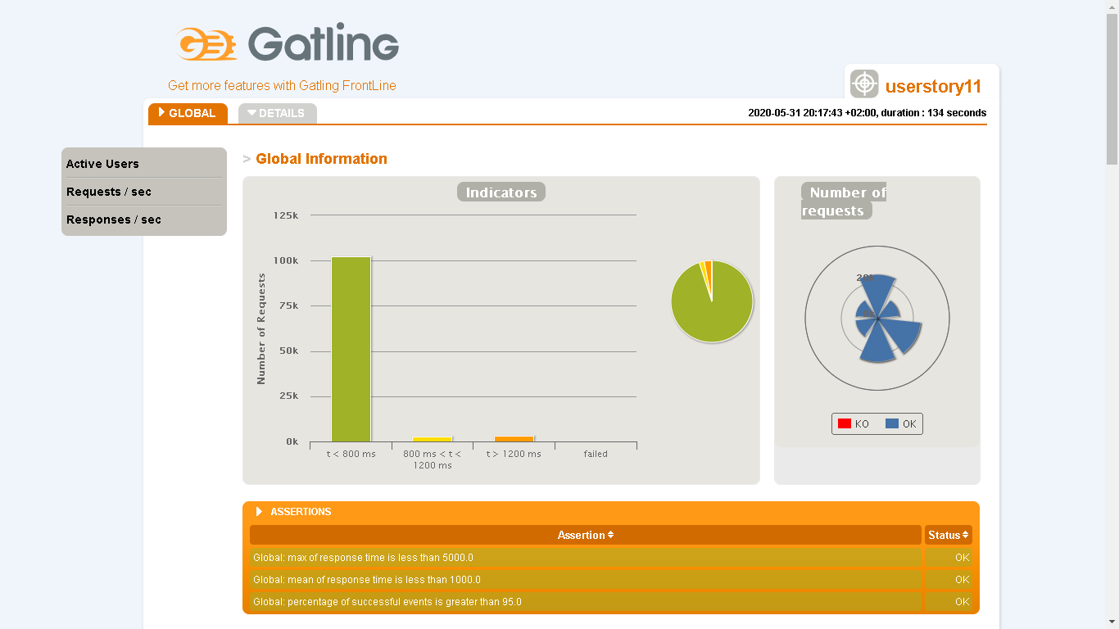

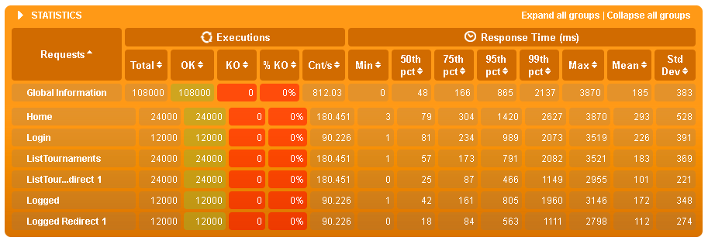

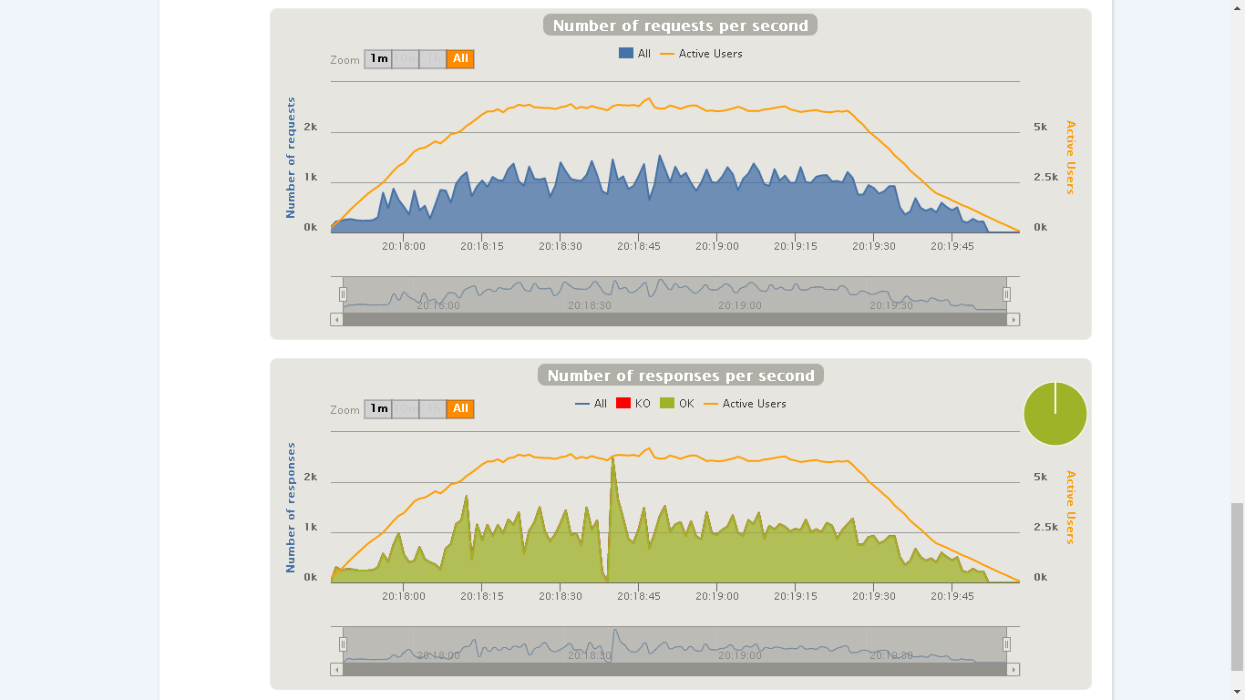

## Conclusions

User story almost the same as the previous one where it only changes the tournaments shown, clearly it is expected to support a larger number of users than the previous story and the results support that idea, the user story has a good and acceptable performance.

# User Story 12 – Throw a application to a tournament

* Positive case: Create a new tournament application with a valid pet and credit card number.
* Negative case: Create a application to a tournament in which the same owner previously sent a application.

## Minimum number of concurrent users that cannot be supported: 8964

Tested for 8000 users for each scenario.

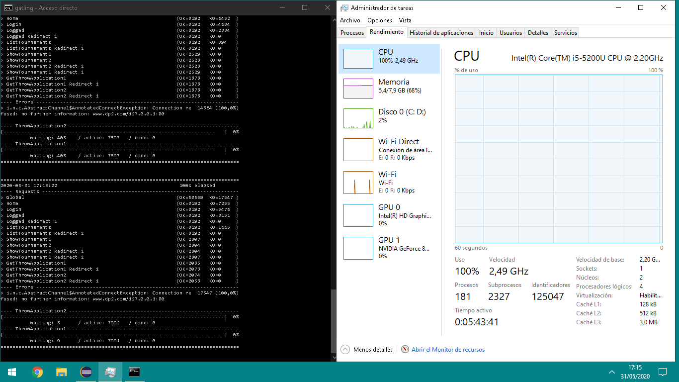

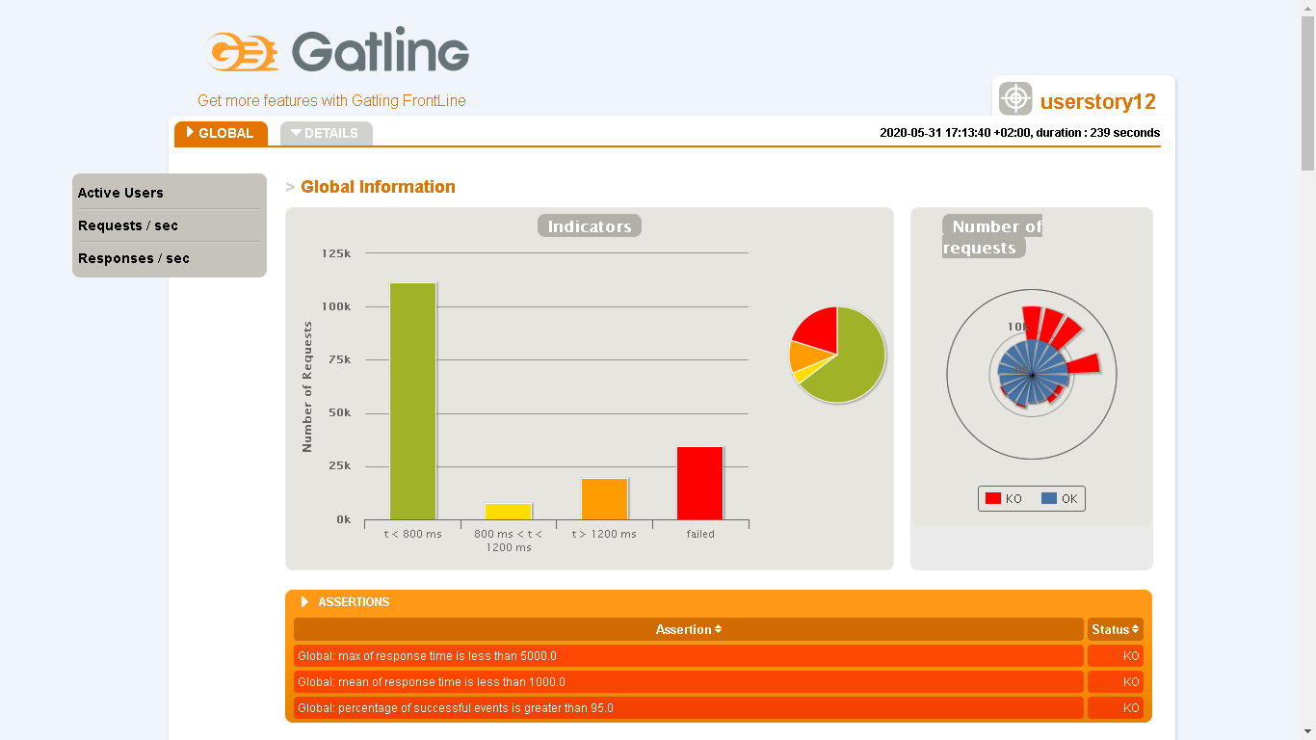

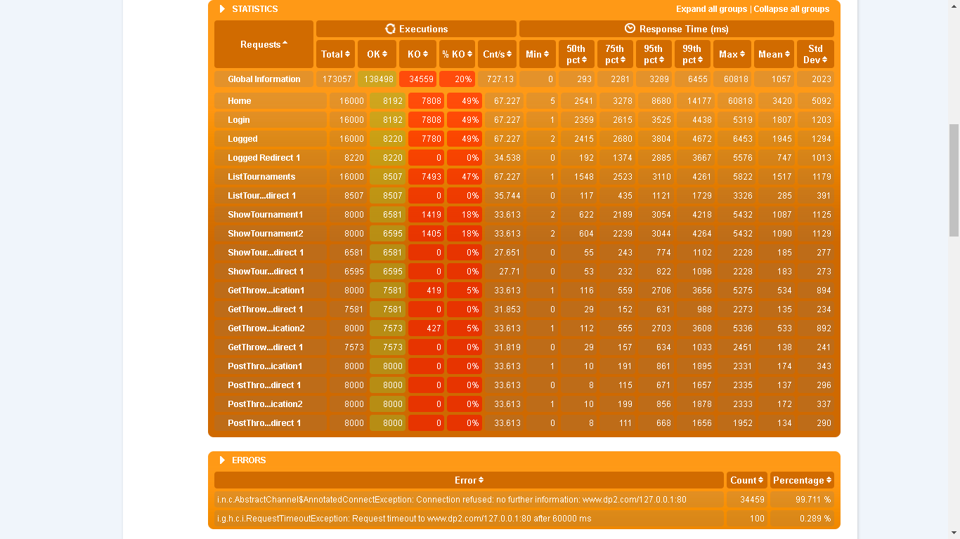

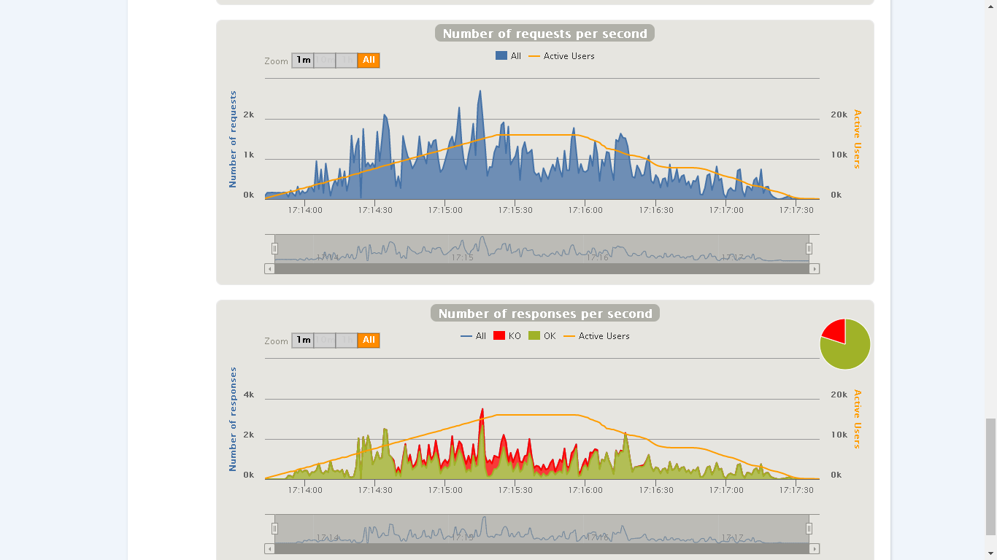

## Maximum number of concurrent users that our scenarios supports: 8000

Tested for 4000 users for each scenario

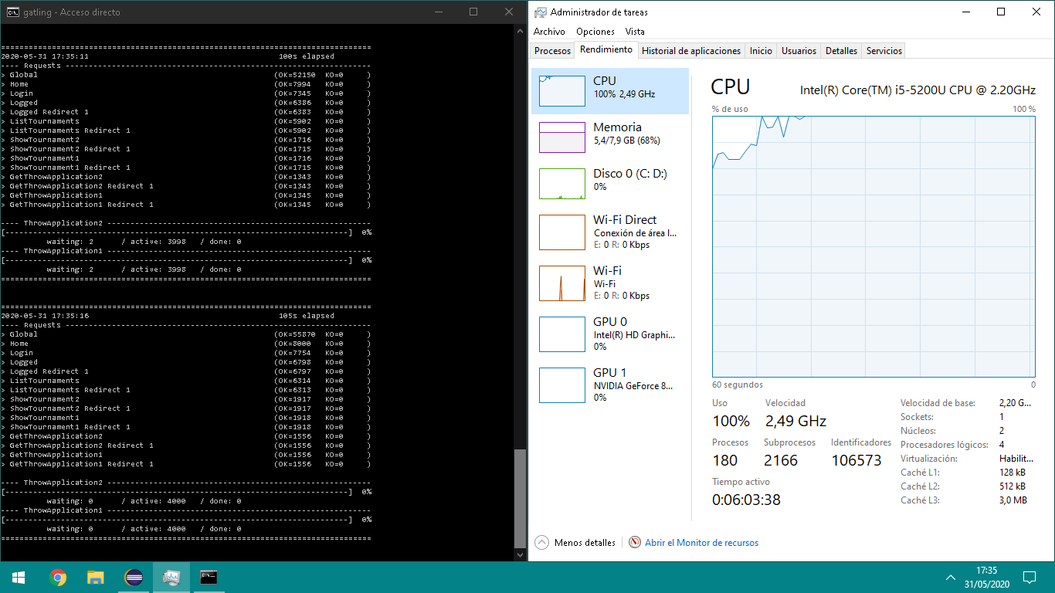

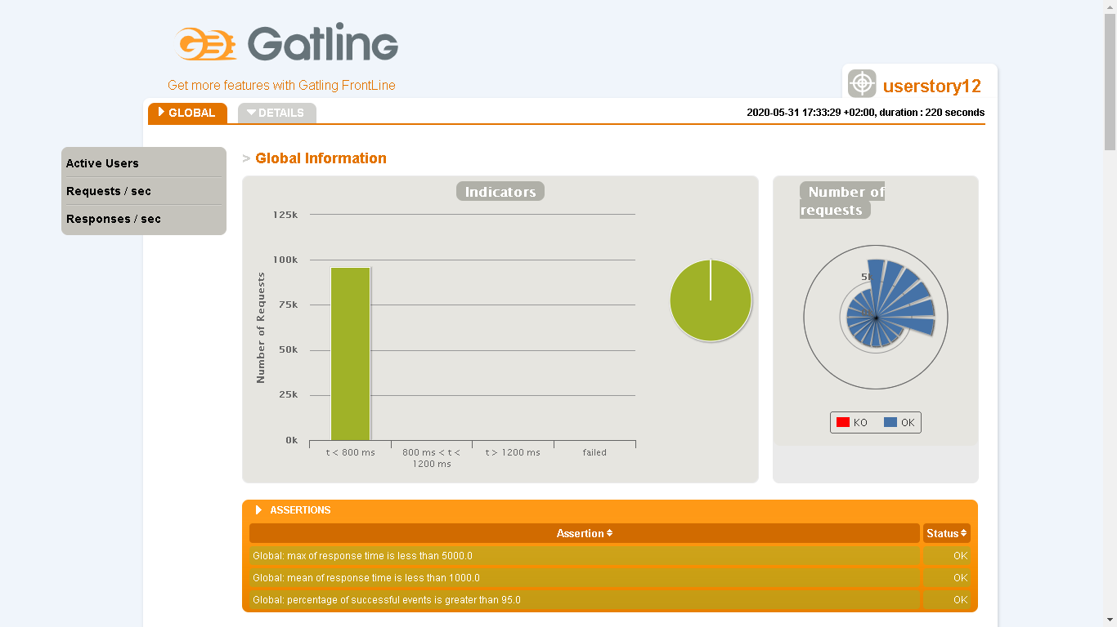

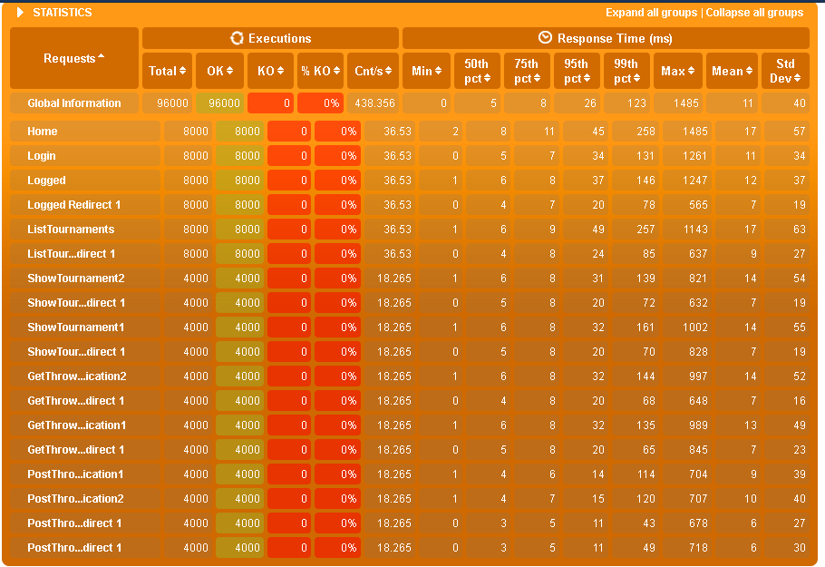

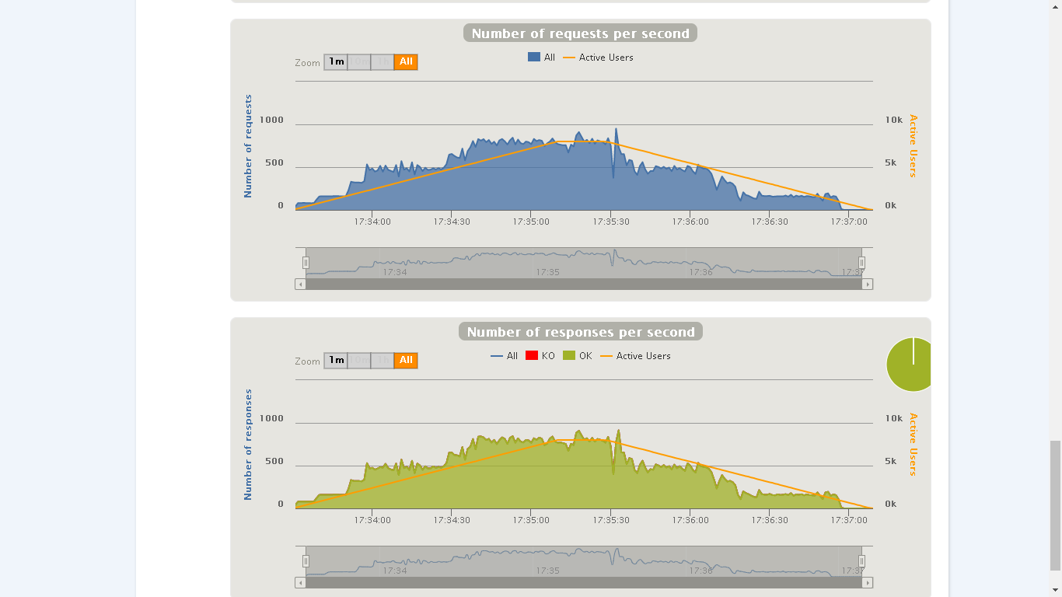

## 

## Conclusions

The results obtained in the performance tests are a little worse compared to the results of the user story 9 but almost, both user stories deal with the same entity, except that in that user story some properties are in readOnly = true , perhaps that is the reason that in this user story it has worse performance.

To finish, it has also been observed that the many transactions to access the list of active tournaments have ended in KOs and, as in other user stories, Login and Home have ended in KOs.

# User Story 13 – List the applications of an owner user

* Positive case: An owner access to the list.
* Negative case: An admin access to the list.

## Minimum number of concurrent users that cannot be supported: 16000

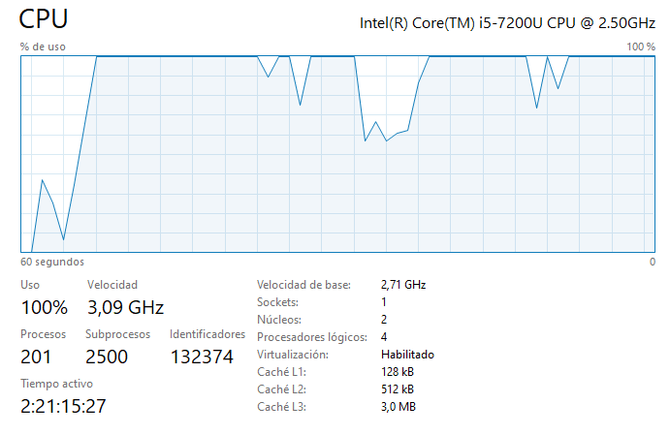

## Maximum number of concurrent users that our scenarios supports: 4050

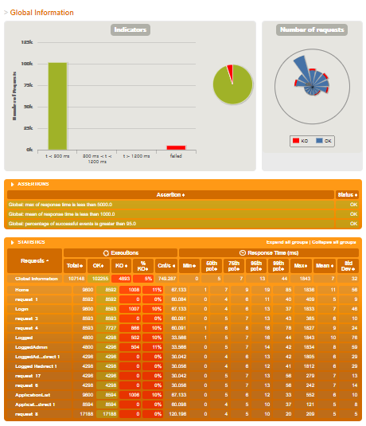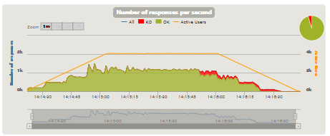

## Conclusions

We can conclude that this user history has medium performance, since it supports 4050 users at the same time, and from 16000 it already gives serious problems.

# User Story 14 – Assign a guide to a pet

* Positive case: When you are authenticated as an Owner , you have your pet with a name "Jewel” and you updates his data assigning it a guide with last name "Justice".
* Negative case: When you are authenticated as an Owner , you have two pets with a name "Jewel" and "Rosy", you assigns a guide to Rosy and tries to changes his name to Jewel so it returns to the form due to duplicated name.

## Minimum number of concurrent users that cannot be supported: 8633

Tested for 9000

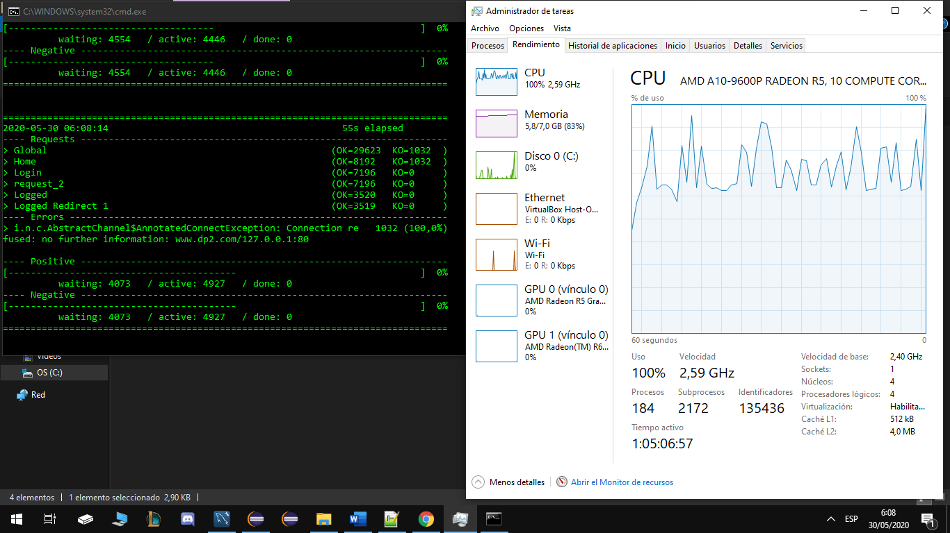

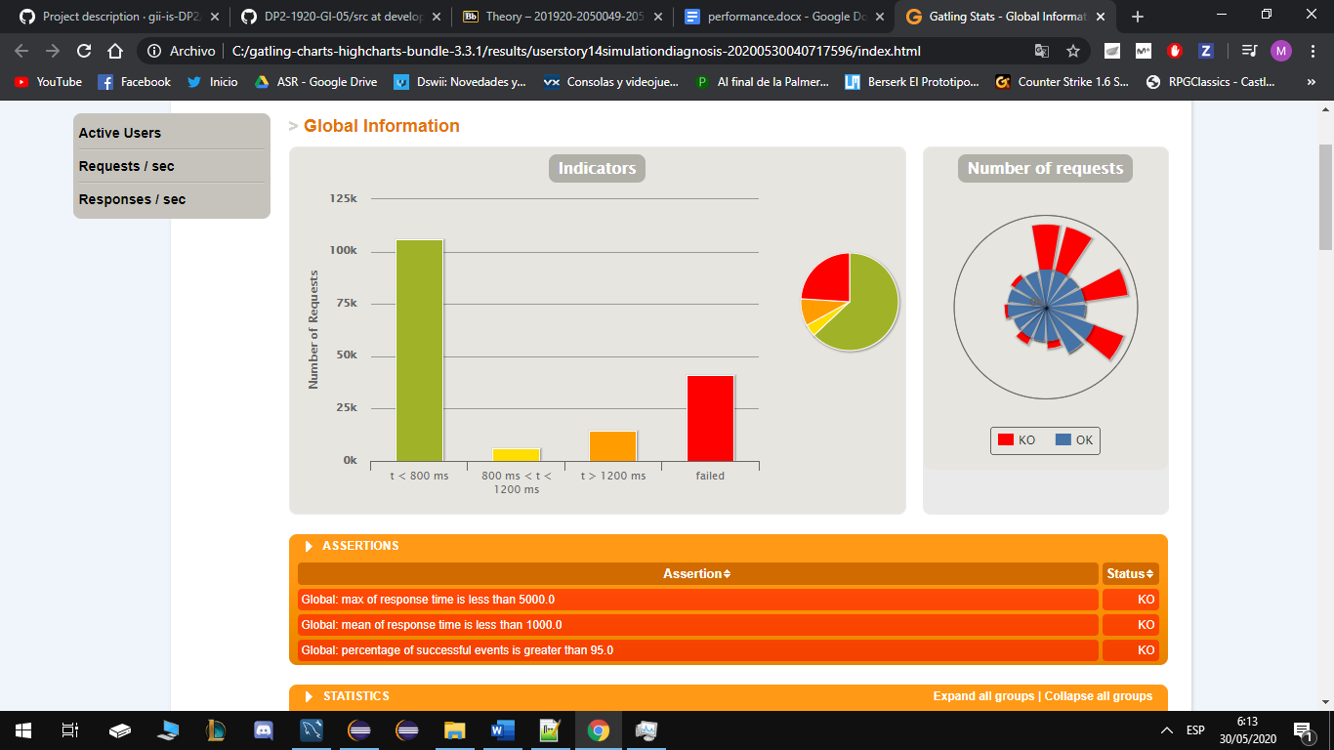

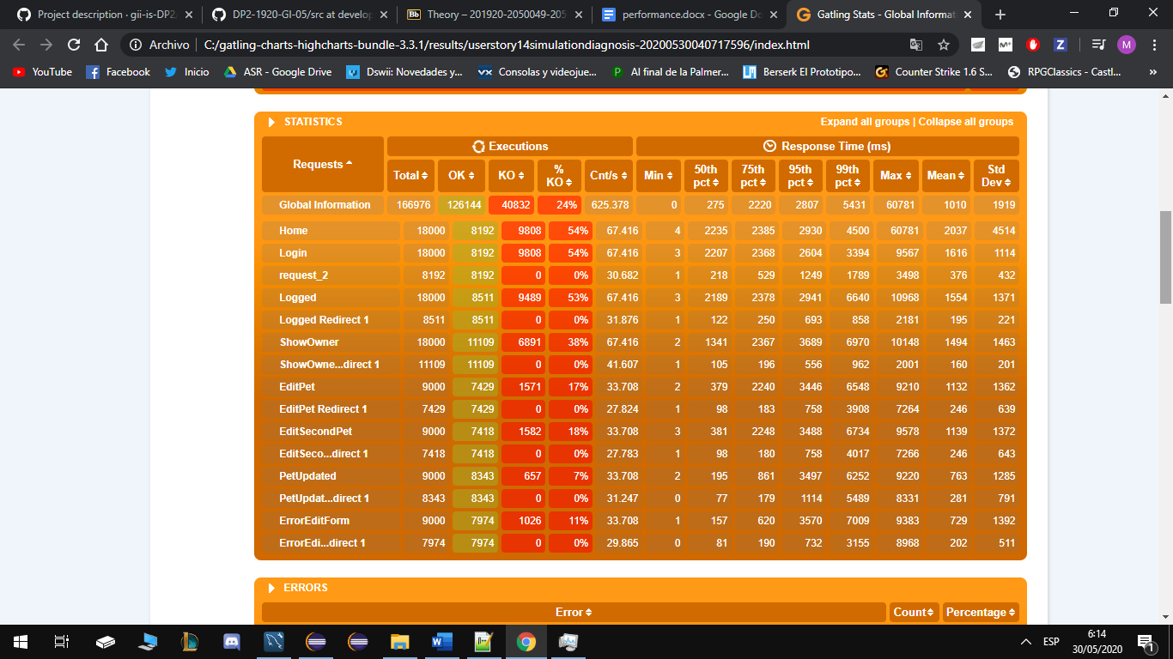

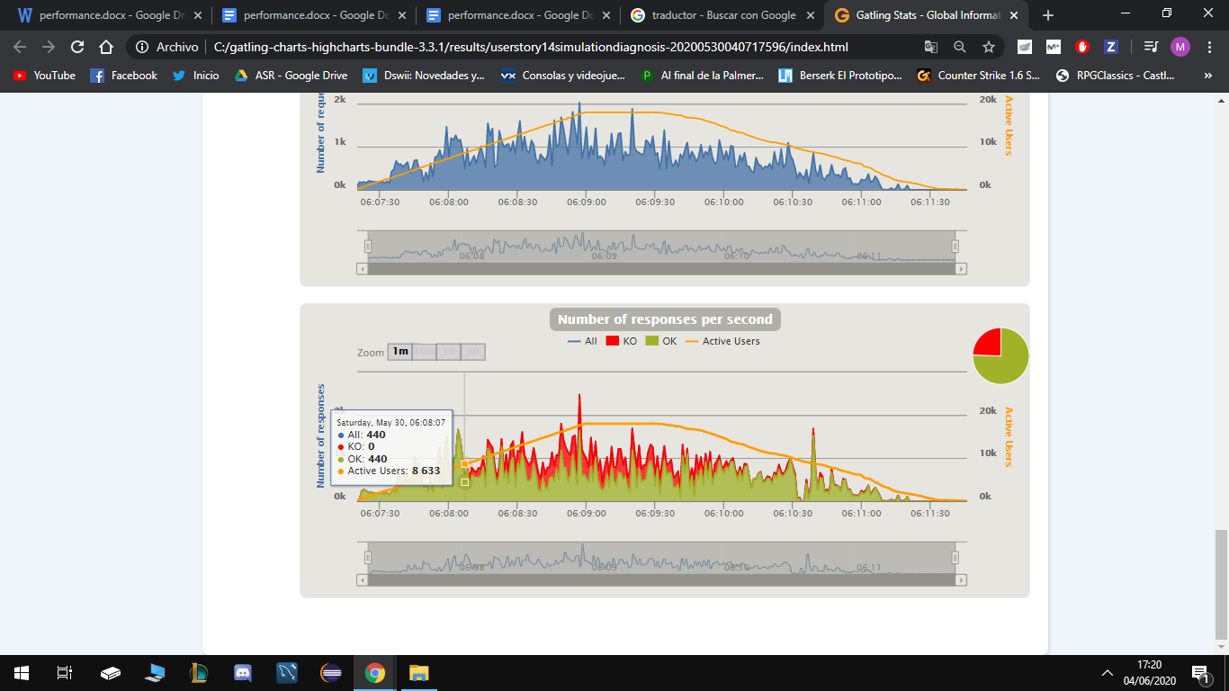

## Maximum number of concurrent users that our scenarios supports: 5042

Tested for 3000 each scenario.

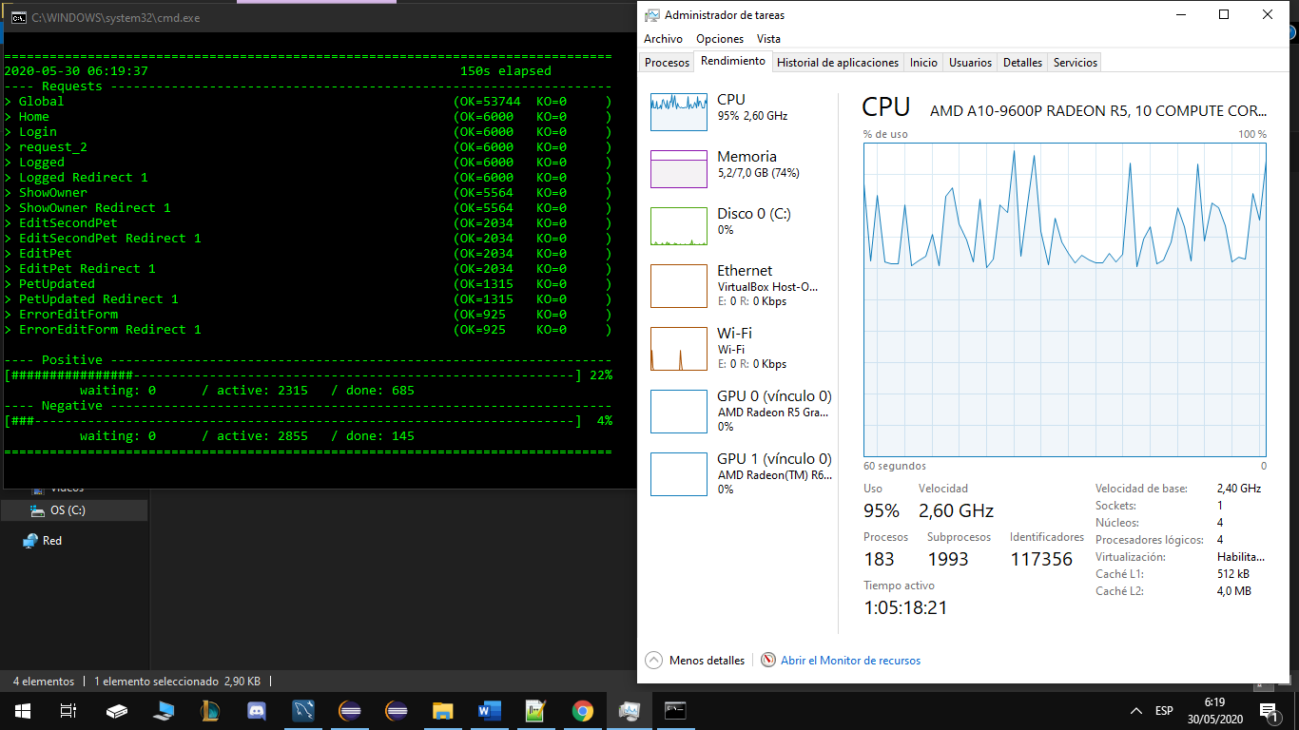

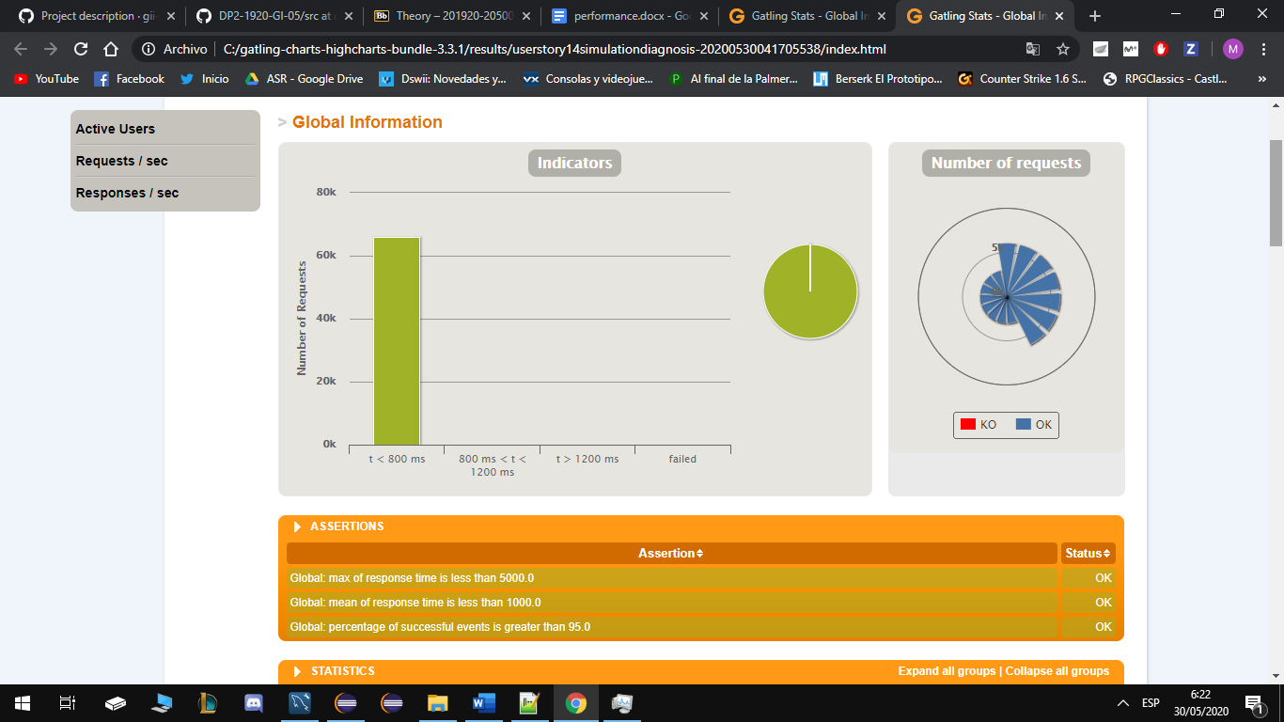

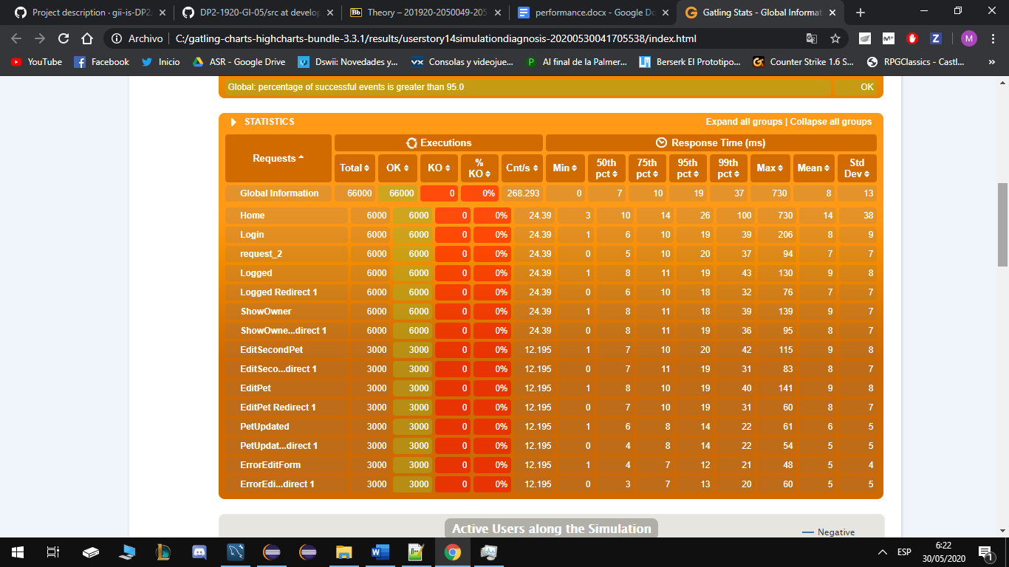

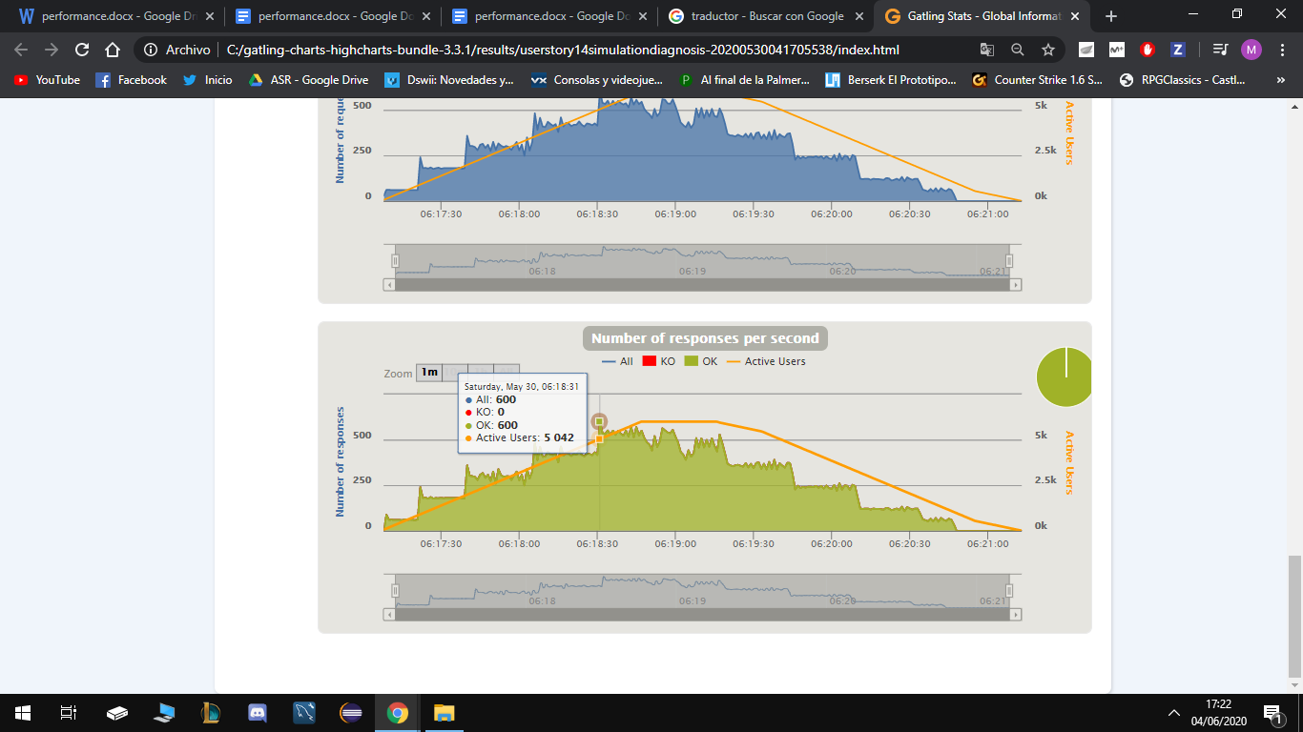

Conclusions

We can conclude that this user history has a good performance, it supports 5042 users at the same time, and from 8633 it already gives problems with my computer’s technical specifications.

# User Story 15 – Show the list of tournament reports of a pet

* Positive case: An admin access
* Negative case: An Owner access

## Minimum number of concurrent users that cannot be supported: 9587

Tried 20.000 owners and 20.00 admins during 100 seconds.

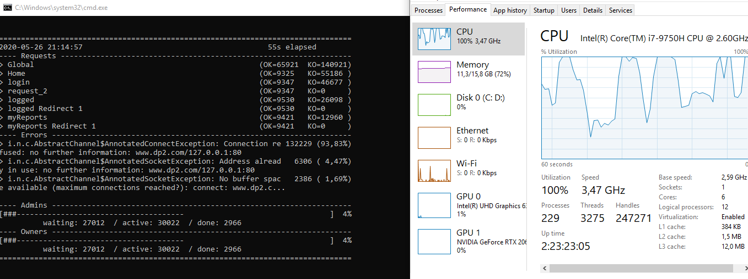

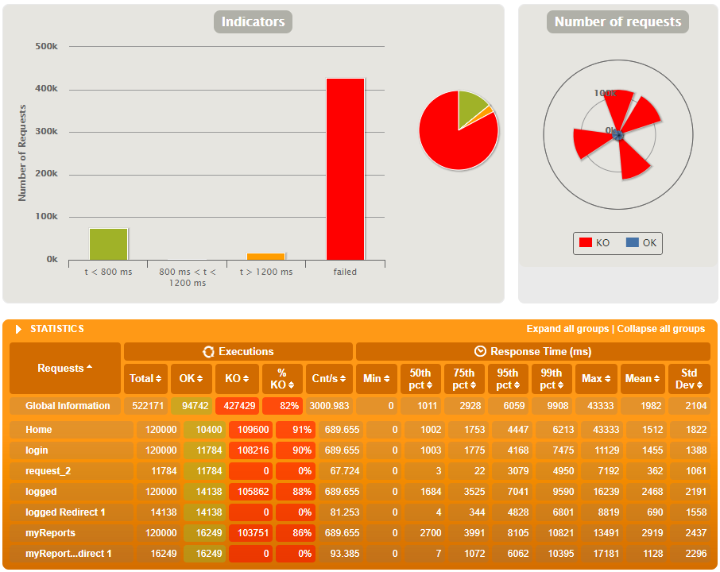

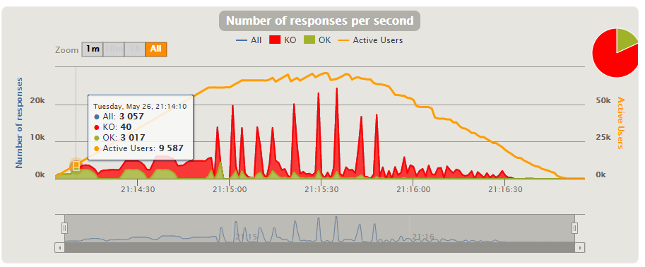

## Maximum number of concurrent users that our scenarios supports: 8688

Tried 5.000 owners and 5.00 admins during 90 seconds.

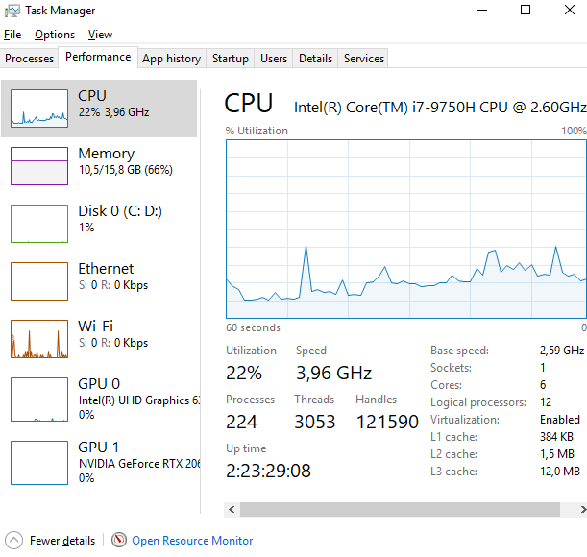

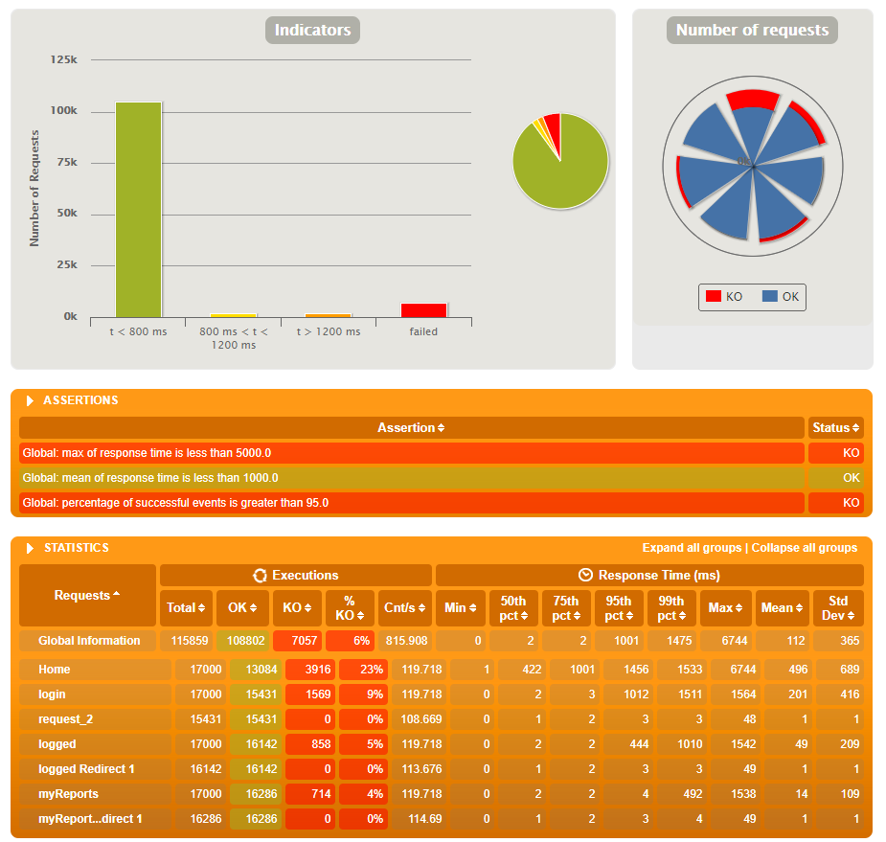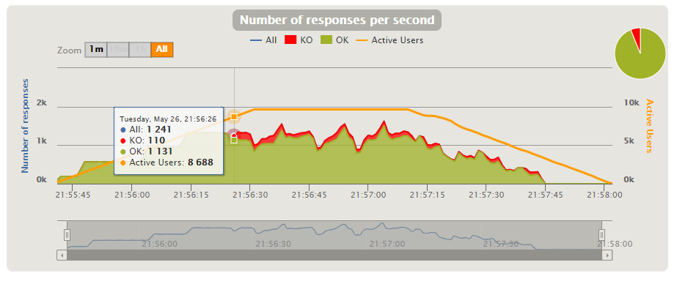

## Conclusions

It’s difficult to get a conclusion from this test, we can’t compare numbers with other tests (except UH-4, UH-5, UH-6, UH-22) since this test was executed in a way more powerful PC than the rest. The results of concurrent users that cannot be supported and concurrent users that this scenario supports are very similar to other tests ran in this PC. So I can conclude that it has an average performance.

# 

# User Story 16 – Create a tournament report for a pet

* Positive case: A judge creates a report.
* Negative case: Judge have no tournament availables to create a report.

## Minimum number of concurrent users that cannot be supported: 16000

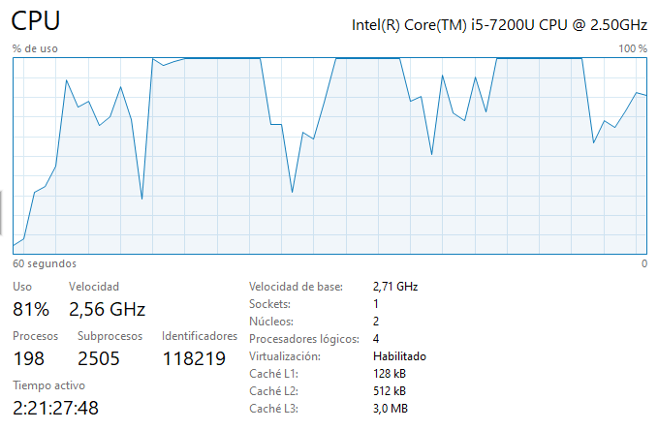

## Maximum number of concurrent users that our scenarios supports: 5560

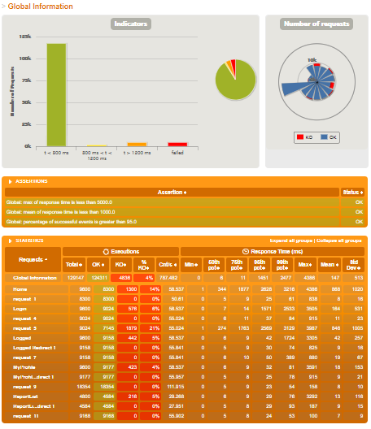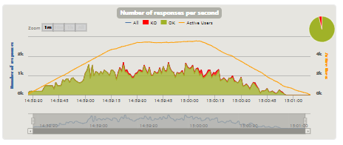

## Conclusions

We can conclude that this user history has a good performance, since it supports 5560 users at the same time, and from 16000 it already gives serious problems.

# User Story 17 – Show the list of tournaments assigned to a judge

* Positive case: A judge want to see his assigned tournaments.
* Negative case: A guide wants to see the assigned tournament of a judge.

## Minimum number of concurrent users that cannot be supported: 5.000

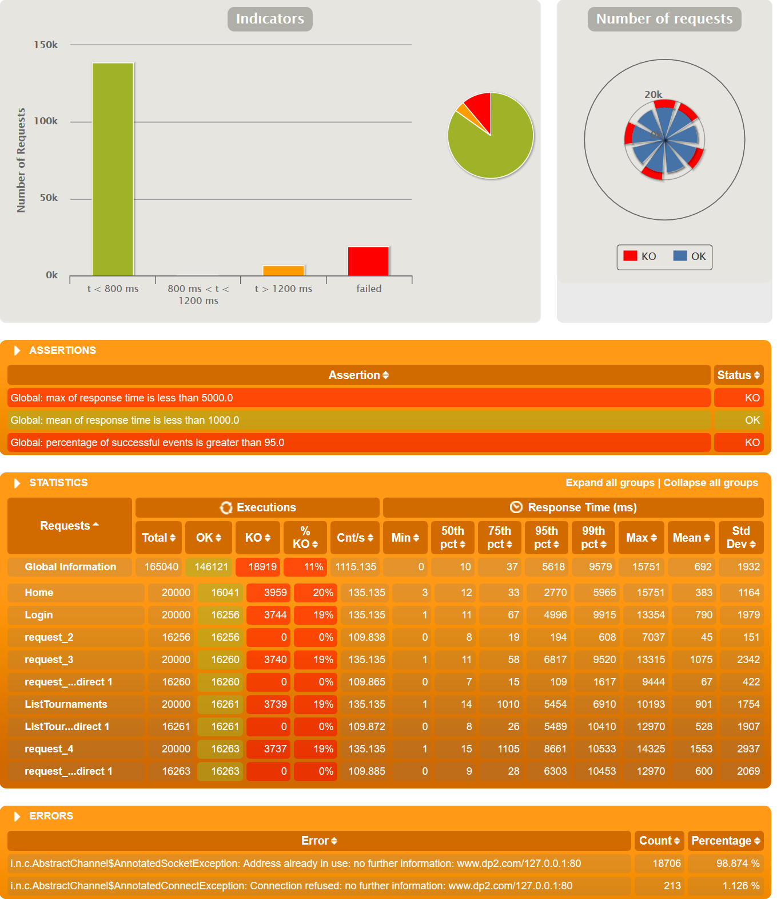

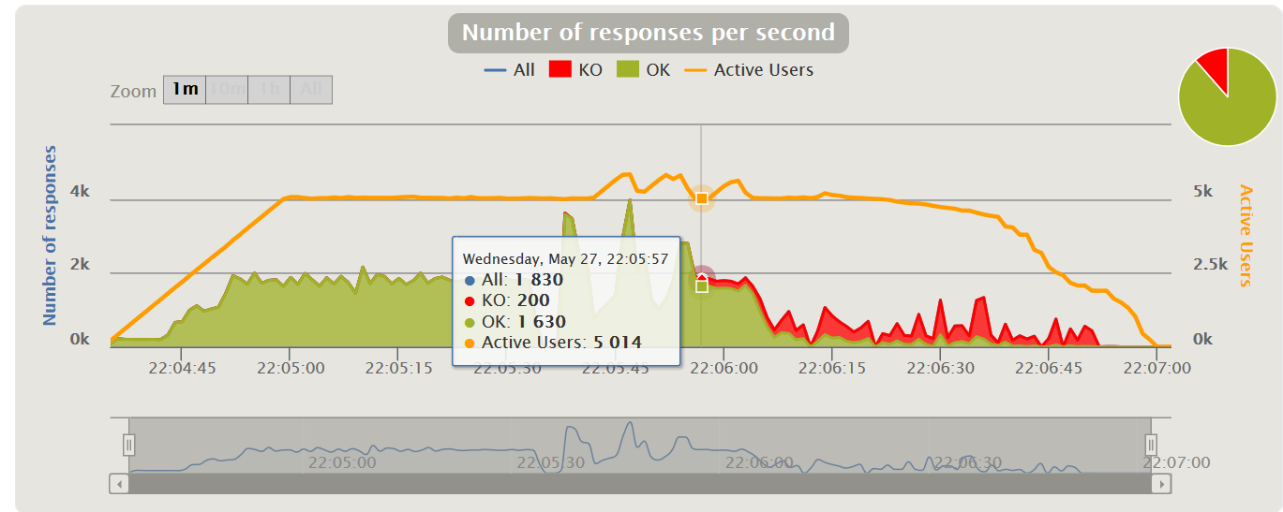

## Maximum number of concurrent users that our scenarios supports: 3.000

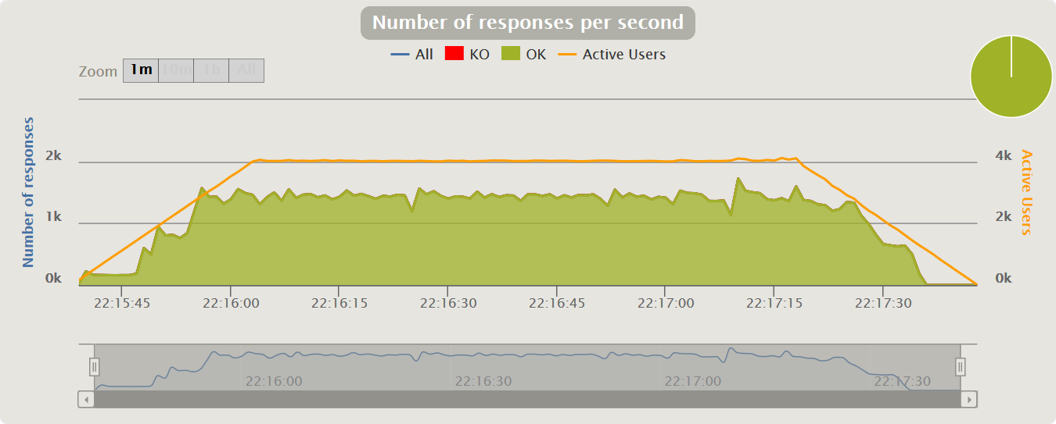

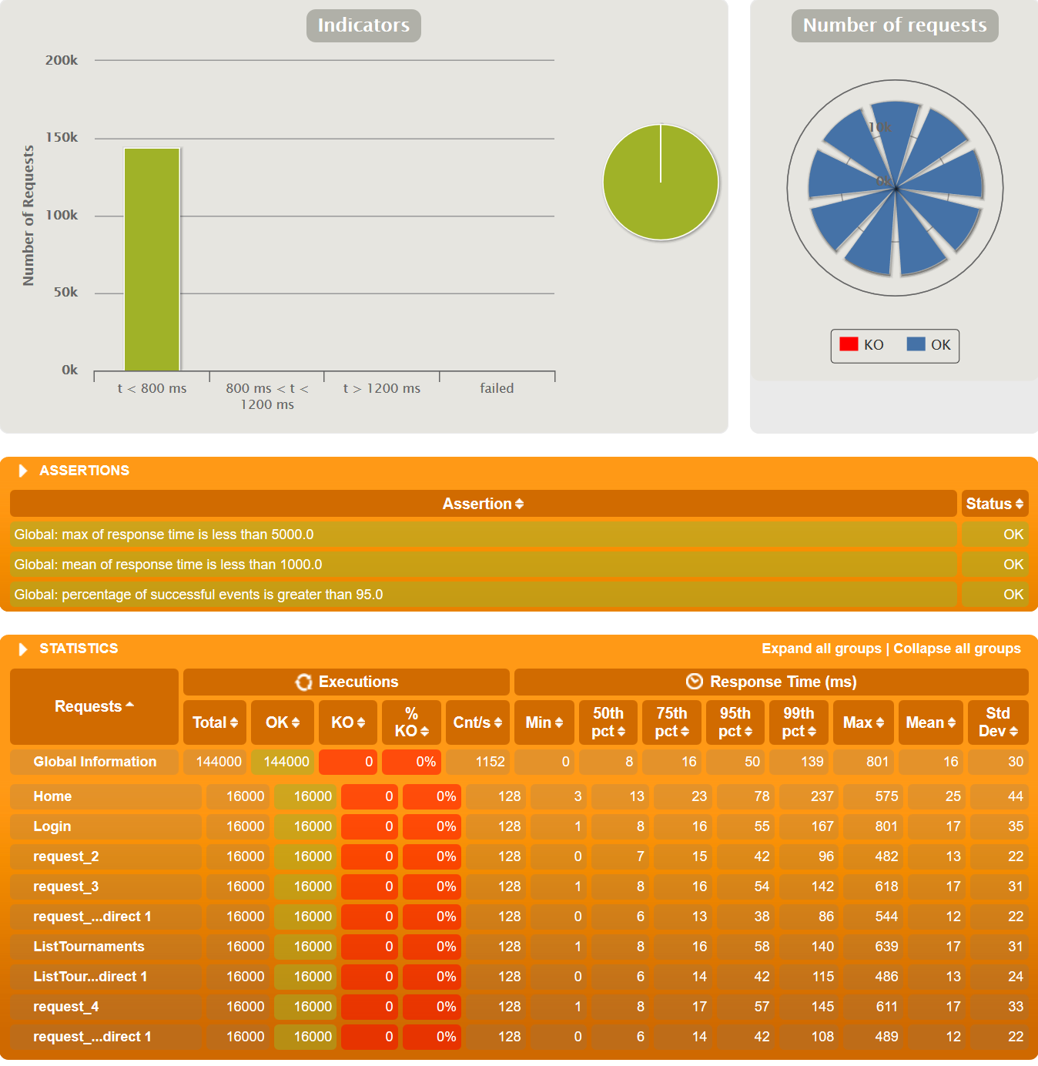

## Conclusions

We can conclude that this user history has a really good performance, since it only supports 3.000 users at the same time, and from 5.000 it already gives serious problems.

# User Story 18 – Show the list of reports created by a judge

* Positive case: The judge see the list of reports.
* Negative case: The judge have no report to list.

## Minimum number of concurrent users that cannot be supported: 20000

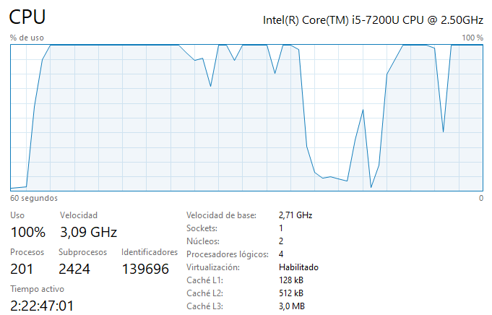

## Maximum number of concurrent users that our scenarios supports: 3616

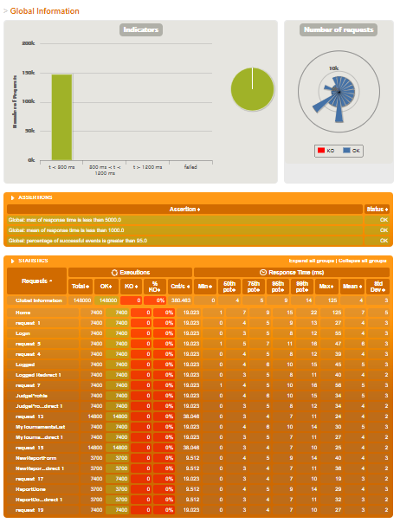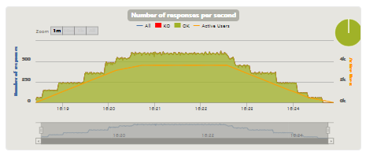

## Conclusions

We can conclude that this user history has a bad performance, since it supports 3616 users at the same time, and from 20000 it already gives serious problems.

# User Story 19 – Make a ranking for a tournament

* Positive case: The ranking is made correctly.
* Negative case: There are no ended tournaments without ranking.

## Minimum number of concurrent users that cannot be supported: 16000

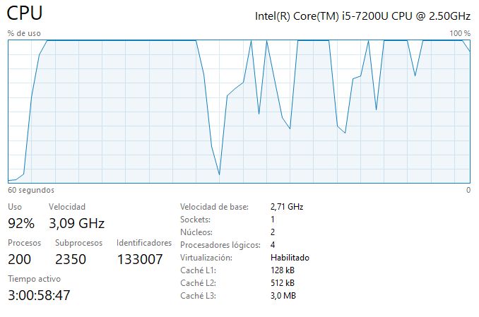

## Maximum number of concurrent users that our scenarios supports: 5806

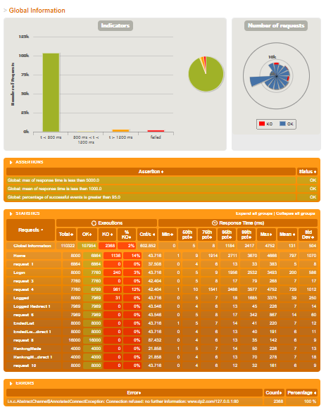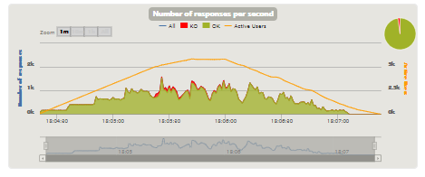

## Conclusions

We can conclude that this user history has really good performance, since it supports 5806 users at the same time, and from 16000 it already gives serious problems.

# User Story 20 – Show the list of pets assigned to a guide

* Positive case: authenticated as an Guide
* Negative case: authenticated as an Judge

## Minimum number of concurrent users that cannot be supported: 9824

Tested for 15000

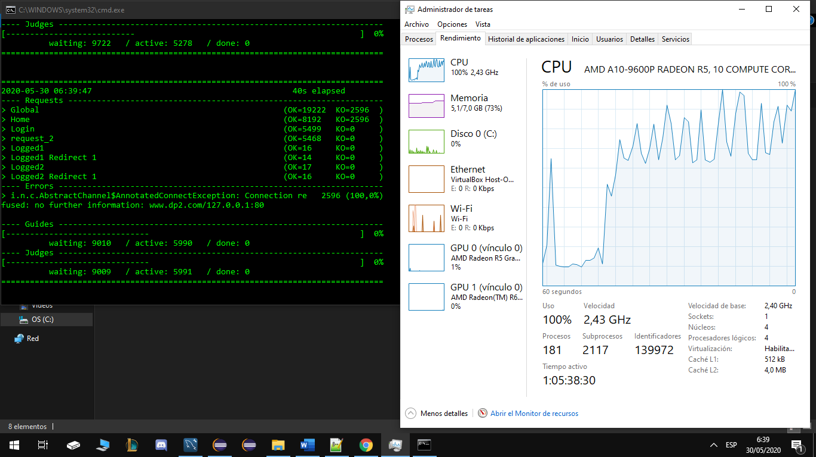

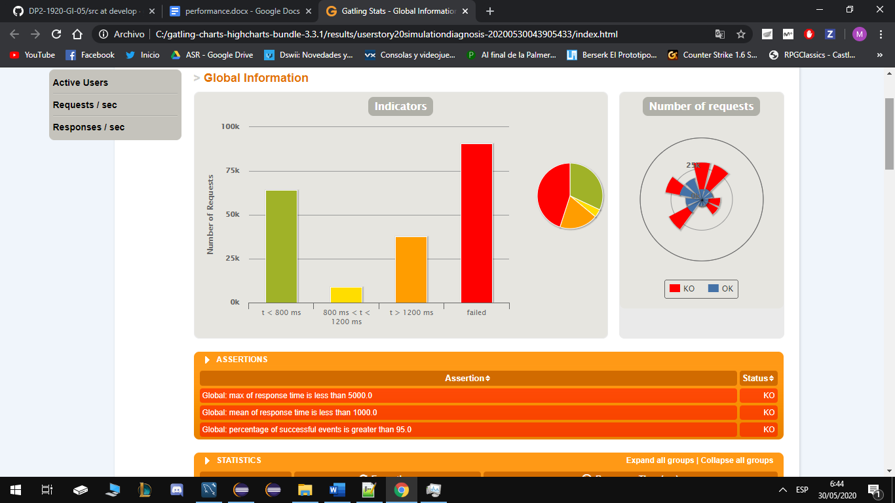

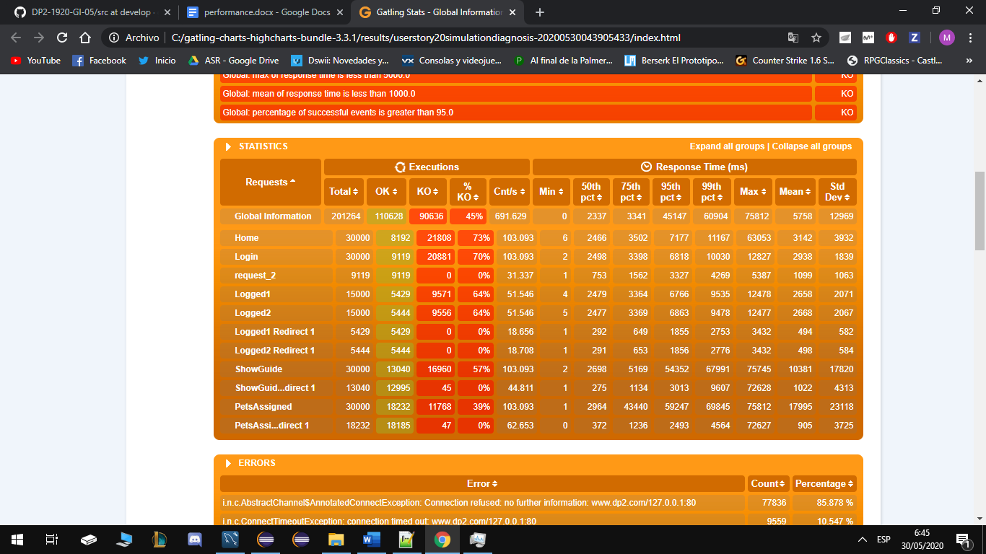

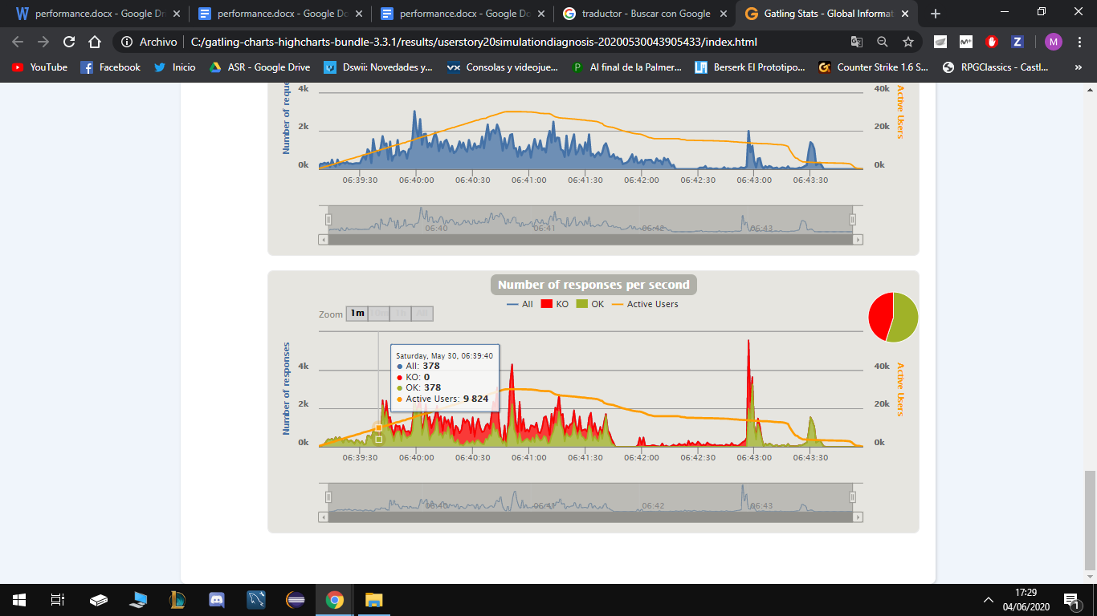

## Maximum number of concurrent users that our scenarios supports: 3918

Tested for 4000

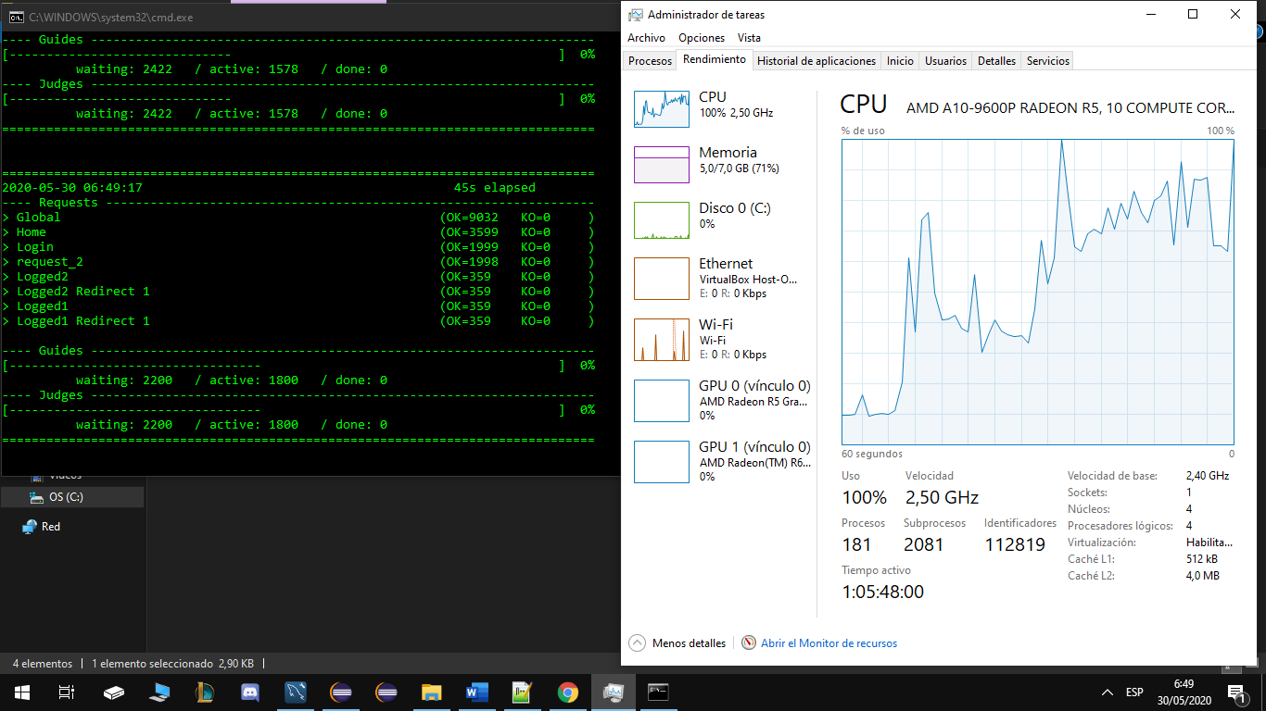

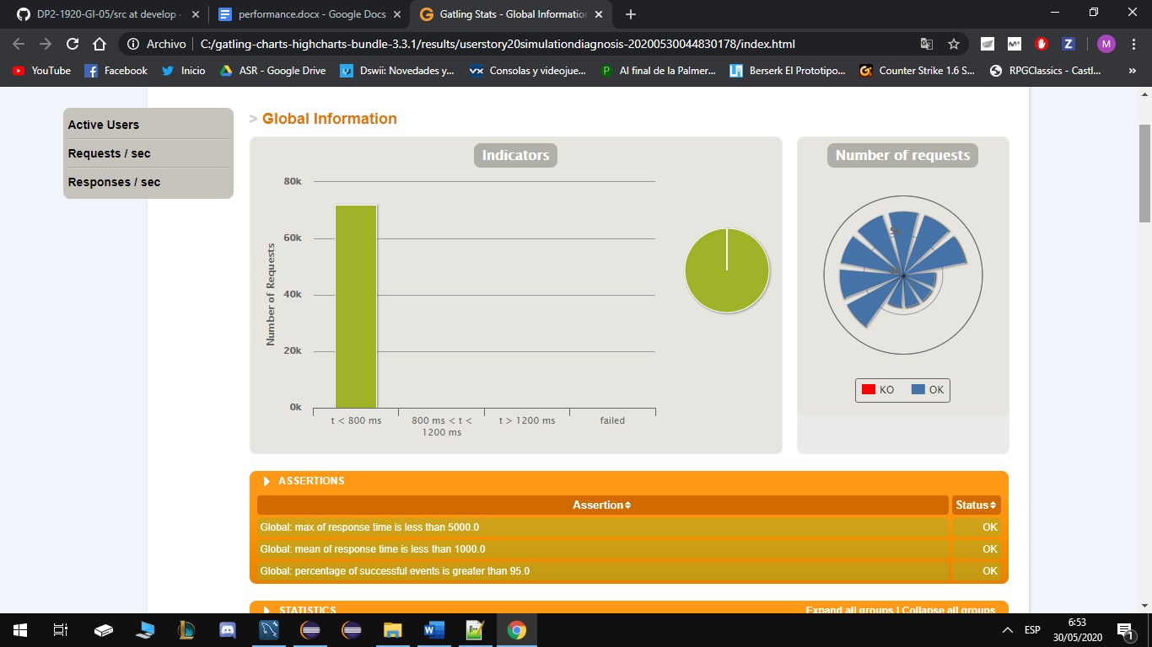

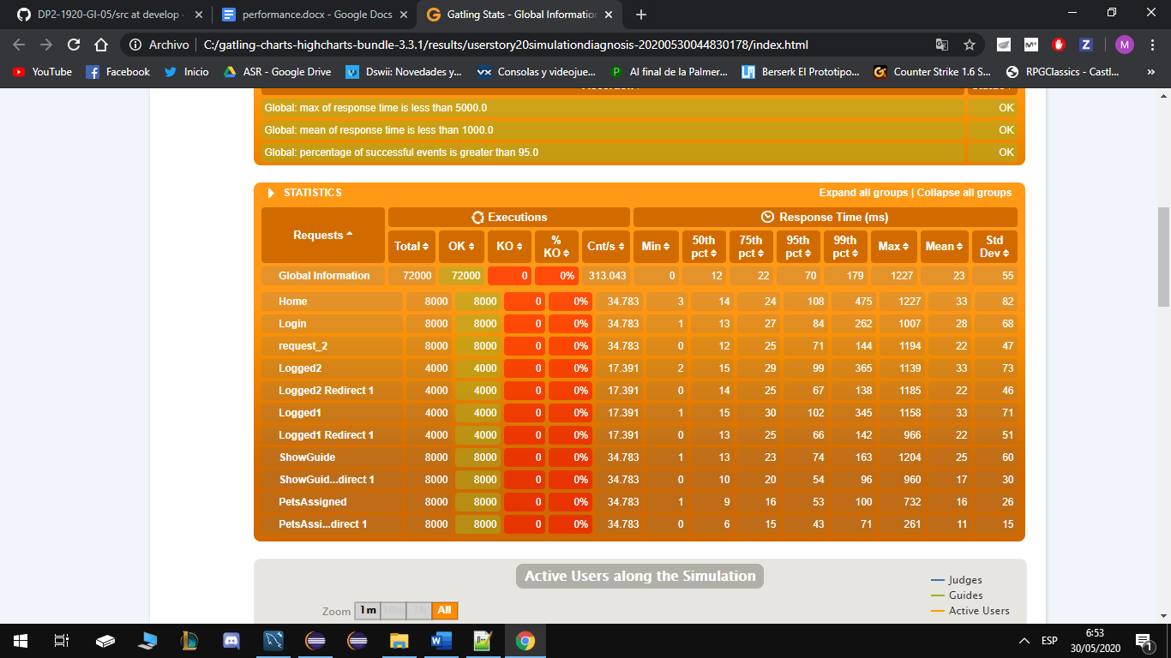

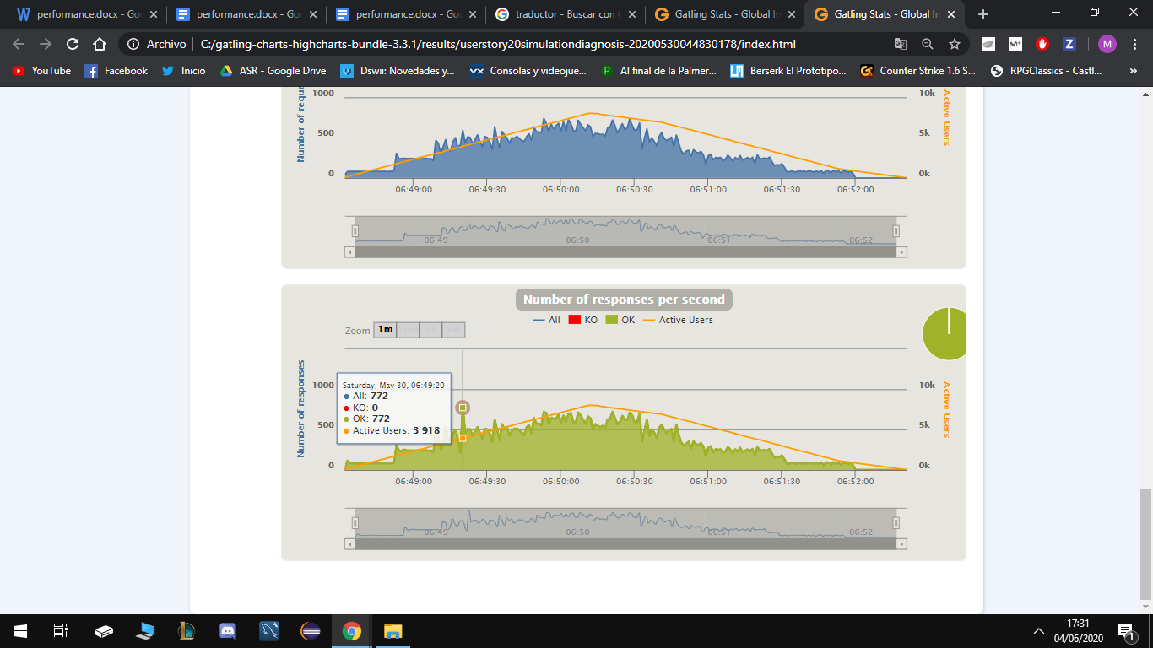

## Conclusions

We can conclude that this user history has a good performance, it supports 3918 users at the same time, and from 9824 it already gives problems with my computer’s technical specifications. If we want to improve these figures we probably need to improve the CPU or RAM

# User Story 21 – Show list of pet reports assigned to a guide

* Positive case: A guide wants to see his reports. 9.000
* Negative case: A judge wants to see his reports of a guide. 8.000

## Minimum number of concurrent users that cannot be supported: 3.070

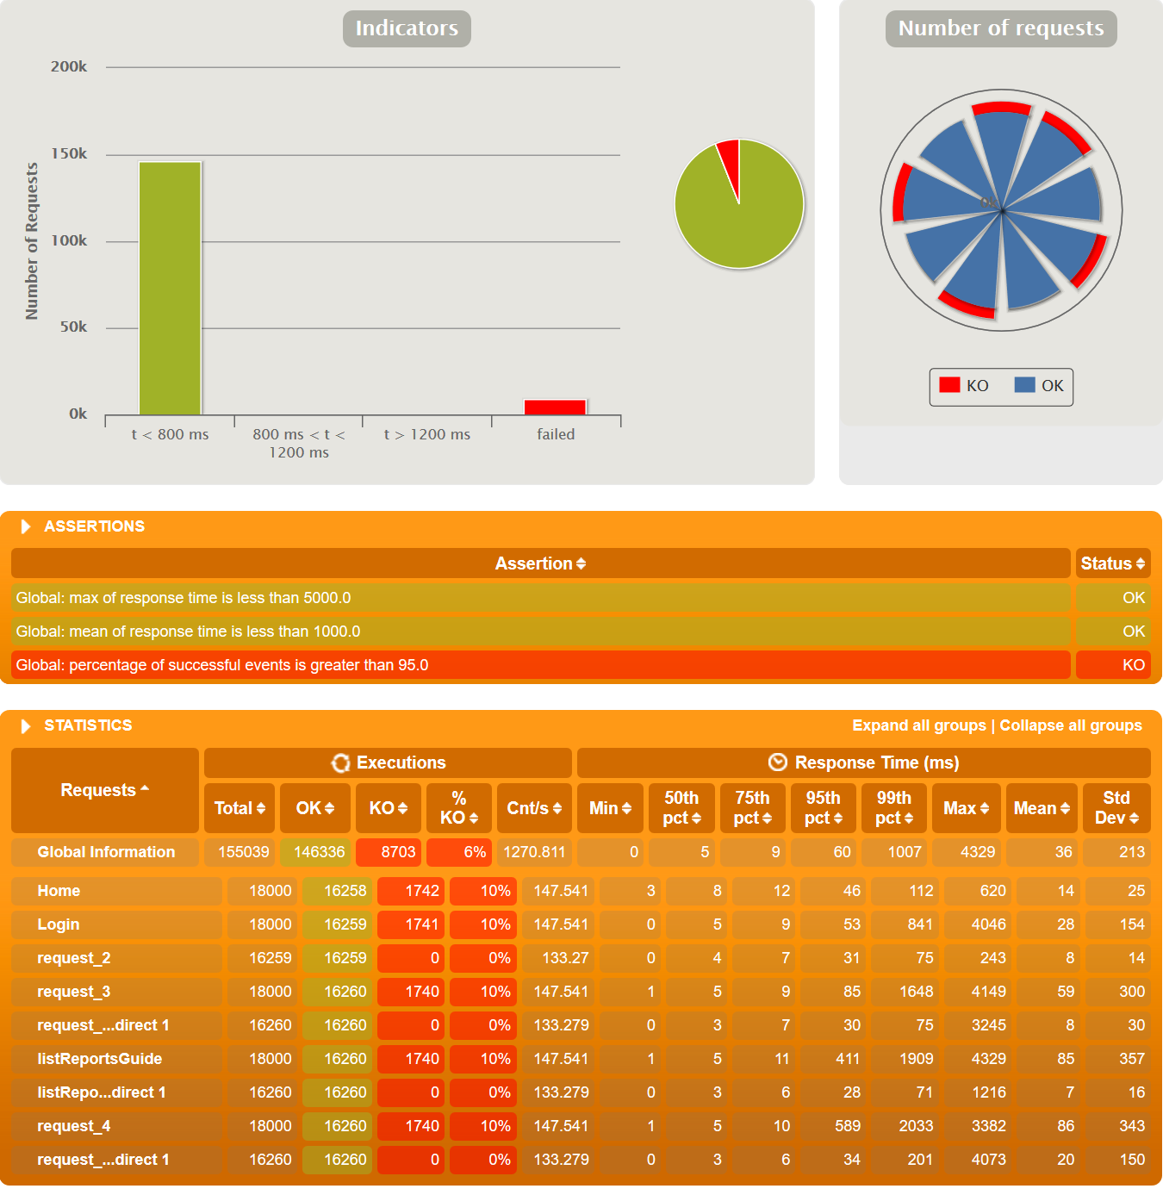

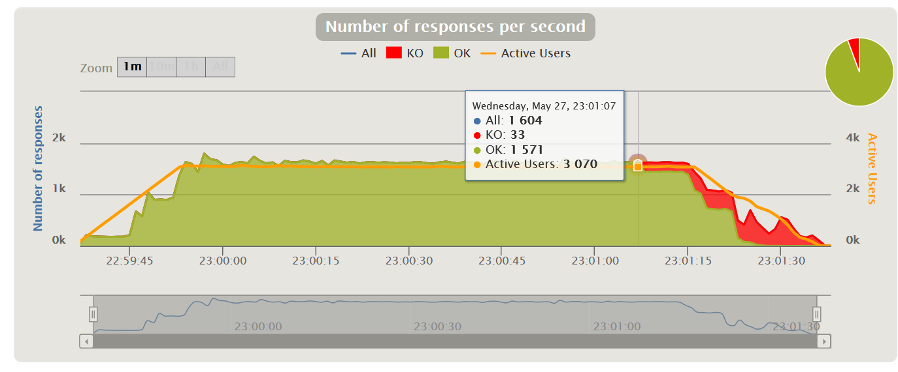

## Maximum number of concurrent users that our scenarios supports: 1.500

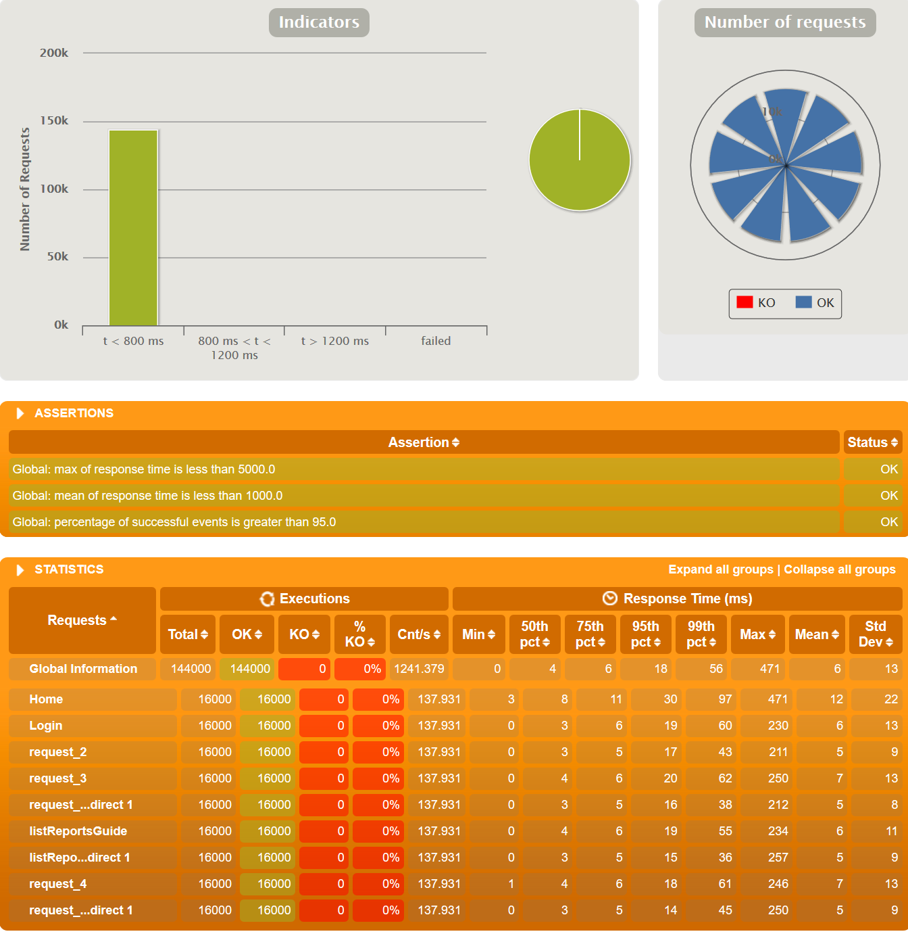

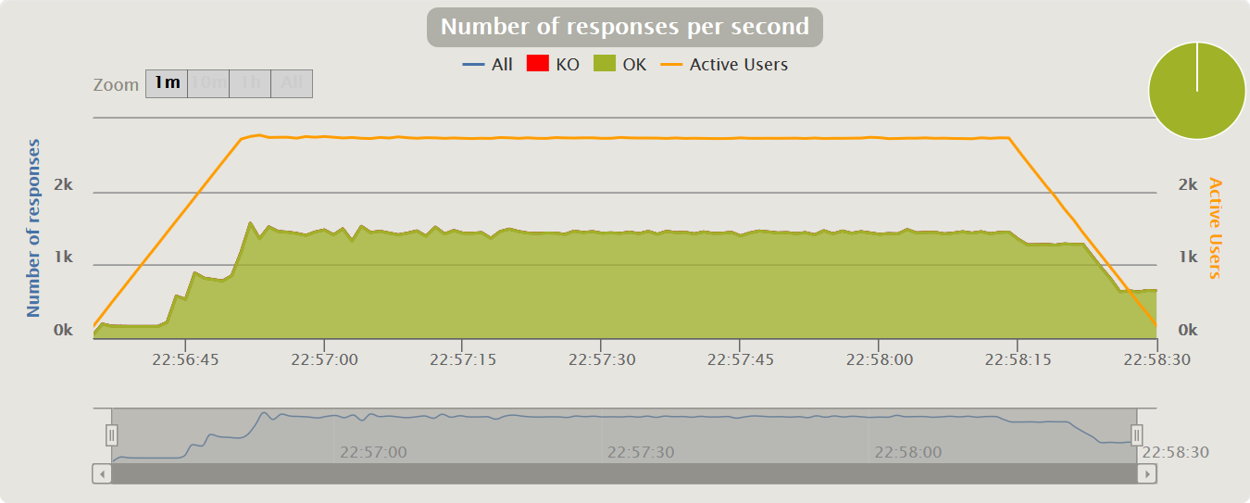

## Conclusions

We can conclude that this user history has quiet bad performance, since it only supports 1.500 users at the same time, and from 3.000 it already gives serious problems.

# User Story 22 – Show the rankings of a tournament

* Positive case: An Owner access the rankings
* Negative case: A guide access the rankings

## Minimum number of concurrent users that cannot be supported: 10.780

Test run with 20000 users (owners and guides) in each scenario during 100 seconds.

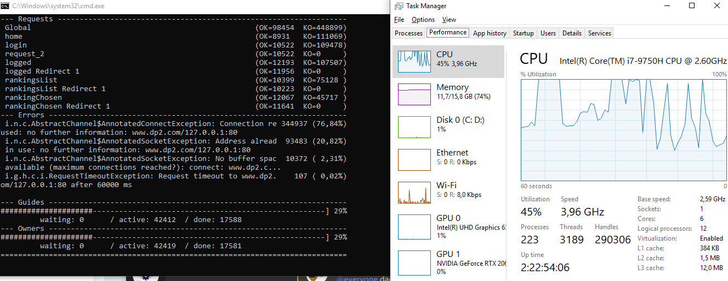

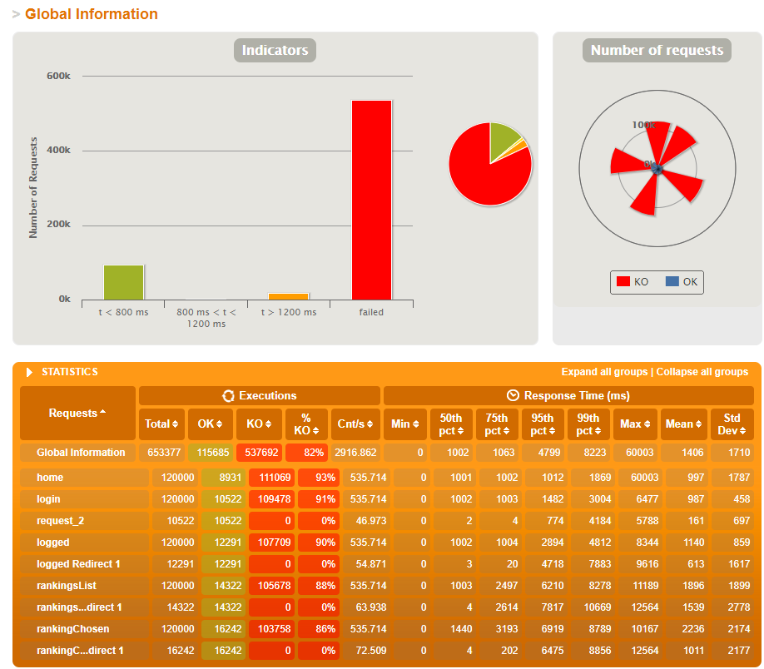

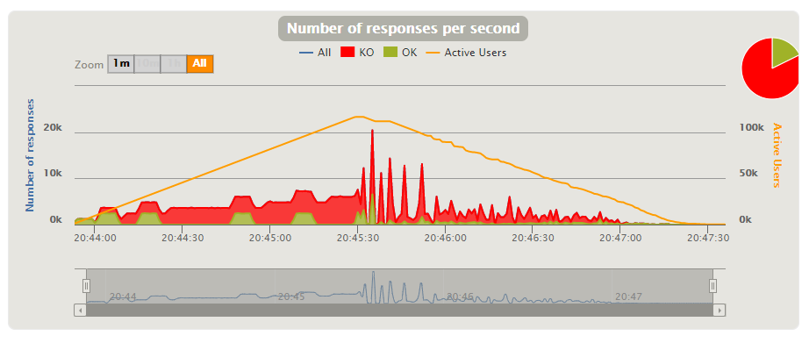

## Maximum number of concurrent users that our scenarios supports: 8500

Test run with 8000 users in each scenario during 100 seconds.

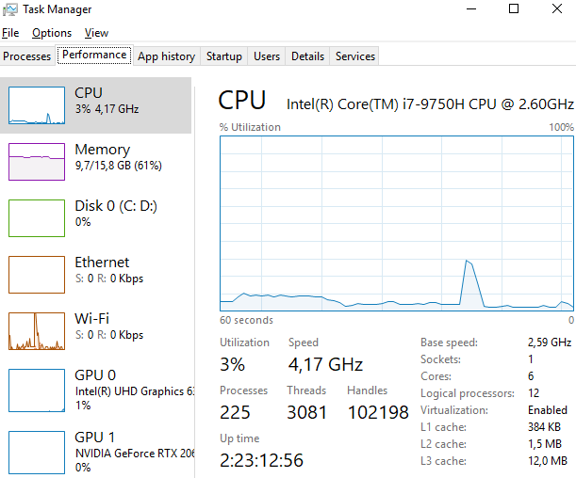

## Conclusions

It’s difficult to get a conclusion from this test, we can’t compare numbers with other tests (except UH-4, UH-5, UH-6, UH-15) since this test was executed in a way more powerful PC than the rest. The results of concurrent users that cannot be supported and concurrent users that this scenario supports are very similar to other tests ran in this PC. So I can conclude that it has an average performance.

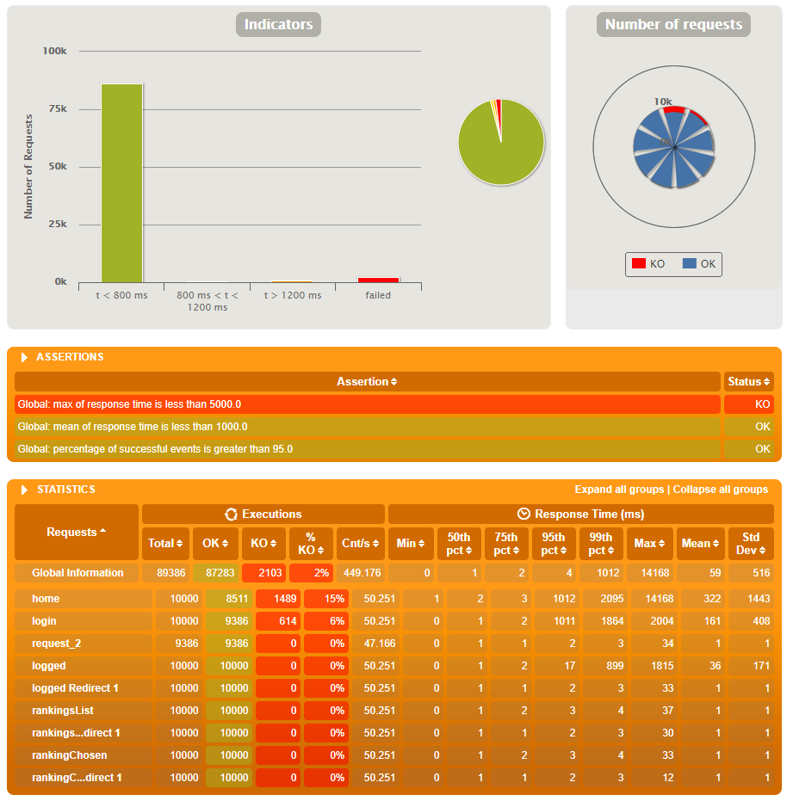

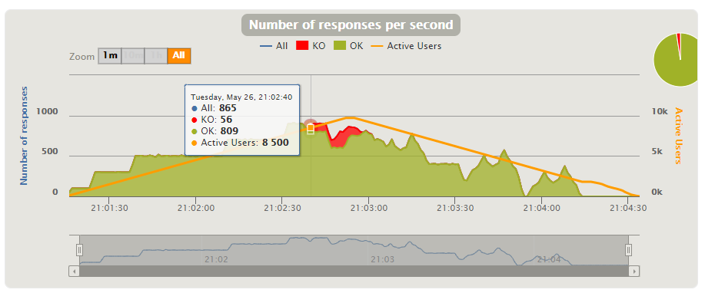

# Final conclusions and results

We also remember in this section that the development of the performance tests has been done according to the user stories that the group members have worked during the Sprints of this project.

The 3 worst performing user stories have been US-1, US-17, and US-21. We found it logical that the first user story have a lower performance than the others since several @modelAttribute are called during their execution and the US-2 has also performed poorly despite being a create of an entity with a single property. Another interesting point that we have seen is that most KOs happen in the home view.

.